The dataset includes 12 variables and 6497 observations, which contains 1599 red wines and 4898 white wines. 11 input variables are the chemical properties of the wine. We divided the project into three main sections. In the first part of project, our group simplifies the data by PCA and plotting the data using several plotting functions to see what it looks like. Use pairs (e.g., 2D plots) or 3 variables (3D plots) based on the packages. We output variable is the score given by at least 3 wine experts rated the quality of each wine, providing a rating between 0 (very bad) and 10 (very excellent). We try. In the second part of the project, we divide your data set into a training set and a test set. Use samples of 50-50, 60-40, and 70-30 for the training-test ratios, and we use different clustering methods such as kmeans, k-nearest neighbor, or one other in the R contributed packages and make tables for better analysis. At last, try data reduction to eliminate some attributes through Principal Components Analysis. The idea is to try and select N attributes that will help you focus on identifying the unsure samples.

**Part 1 Simplify The Datasets**

**1.Load “winequality-red.csv” and “winequality-white.csv” data set.**

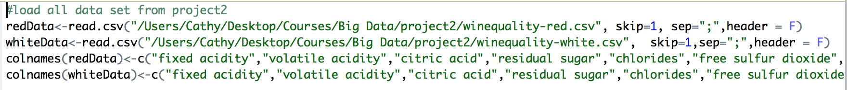

Let’s take red wine data as an example, and have a quick look of the data structure.

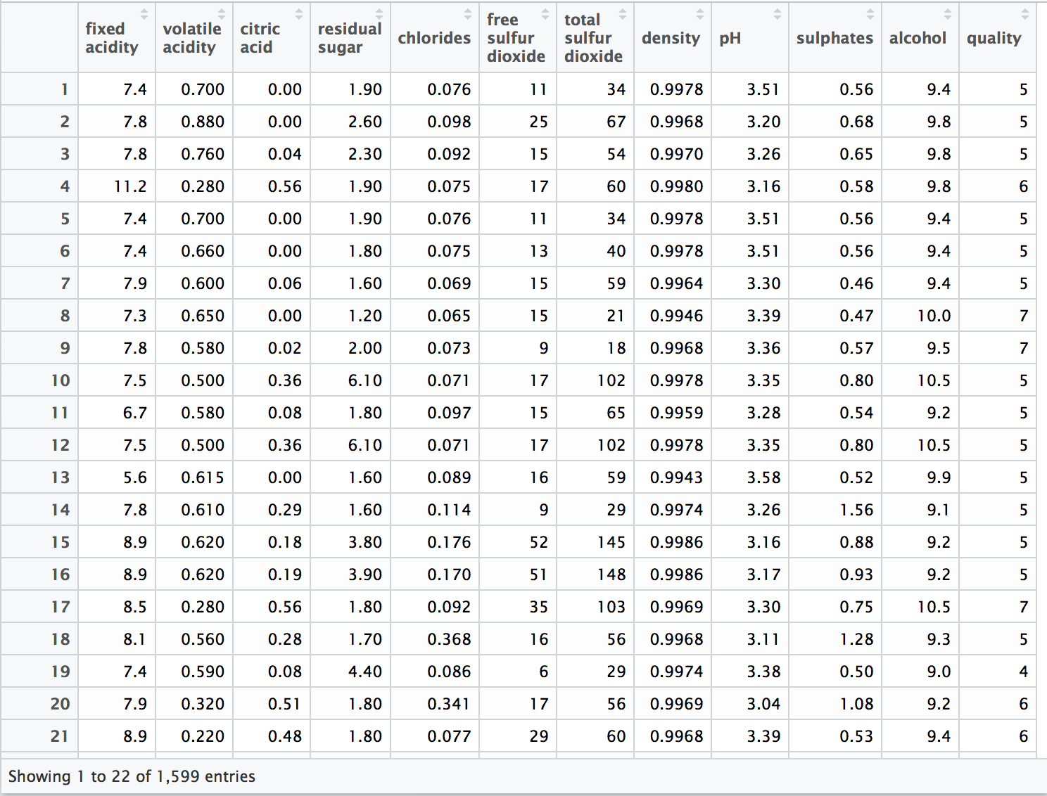

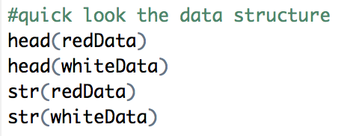

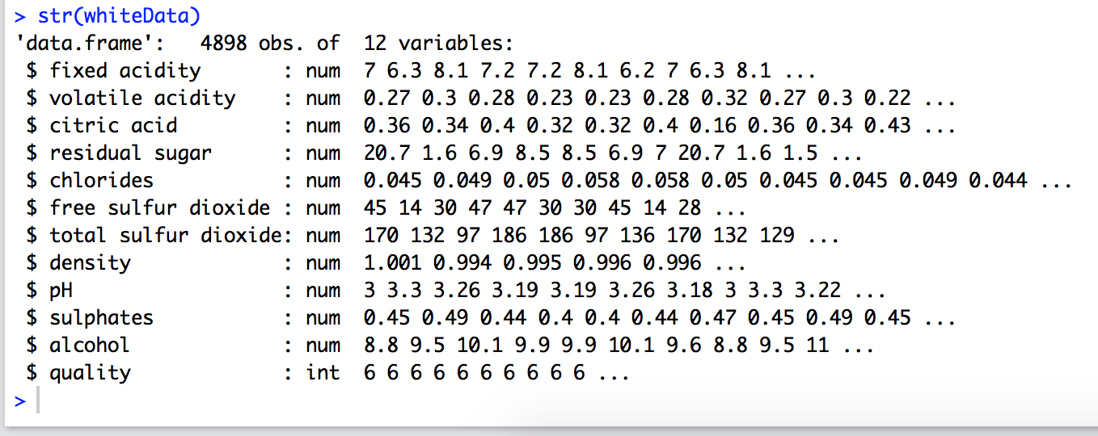

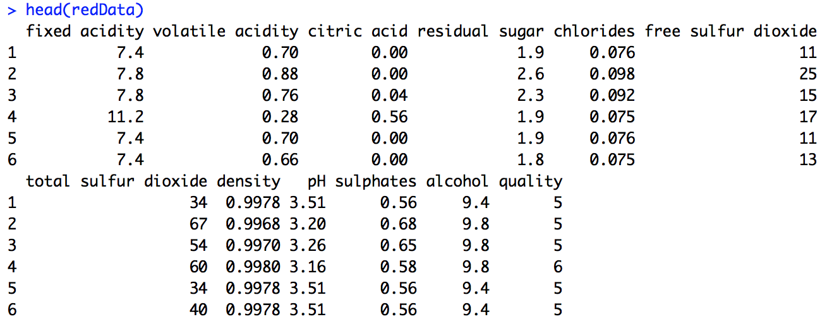

**2. Principal Component Analysis - Using “psych” library and principal() function**

We can use the PCA to reduce the feature, we set the value 4 as the “nfactor” of pc1, and then we change the value to 5 as the “nfactor” of pc2.

a)

library('psych')

pc <- principal(redm, nfactors = 6, scores = TRUE)

pc

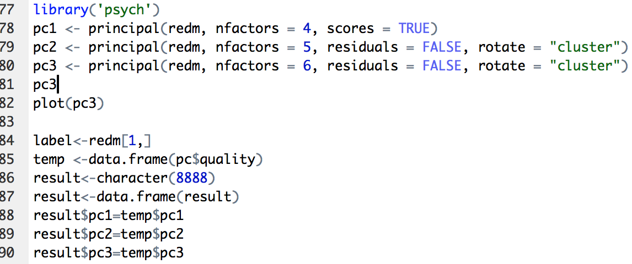

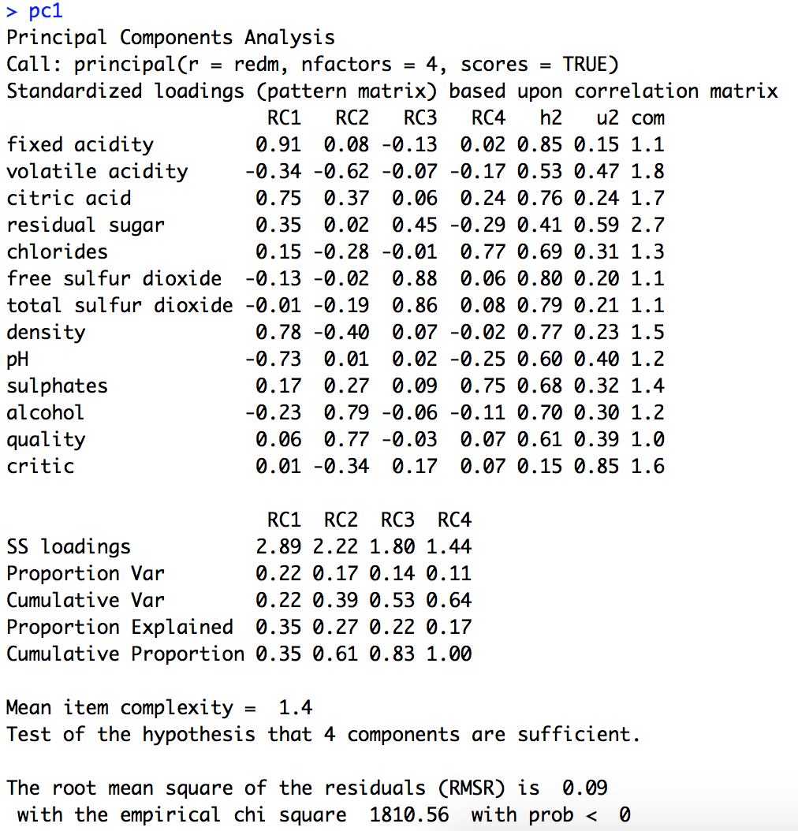

Then, we change the value to 5, and get pc2; and change the value to 6 and get pc3.

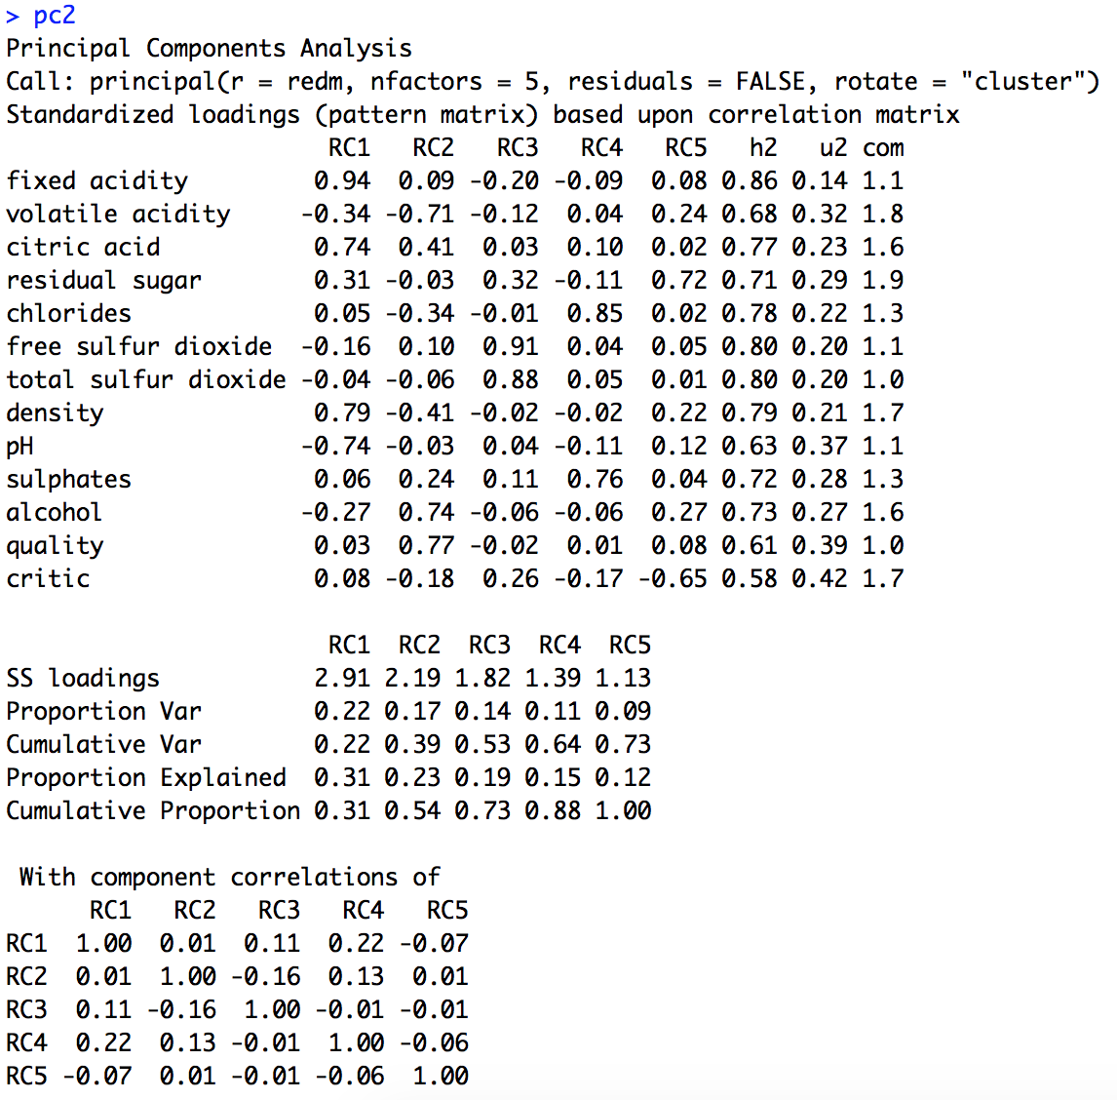

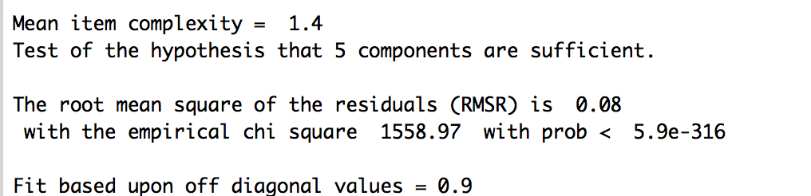

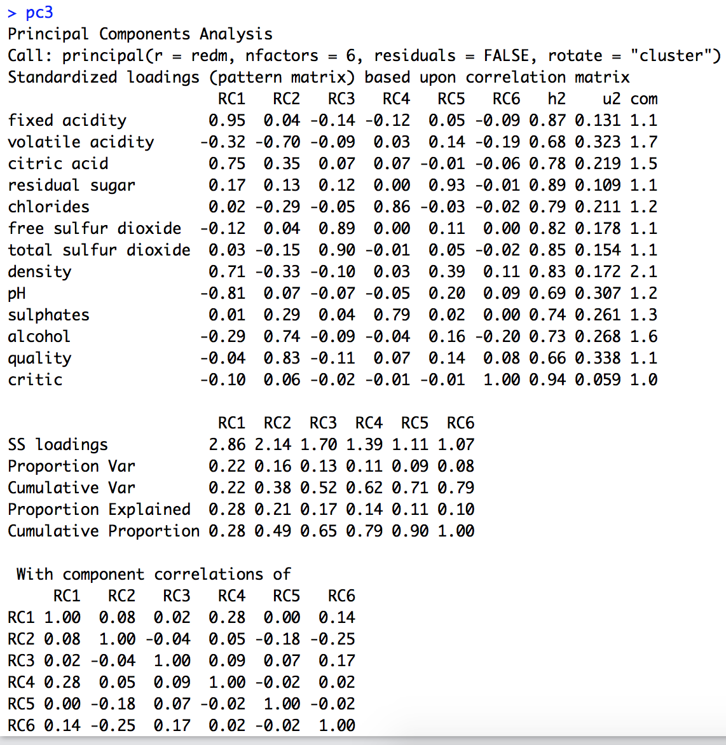

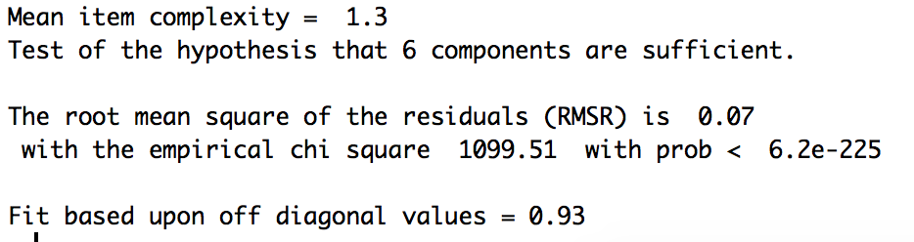

We can see the differences in pc1, pc2 and pc3.

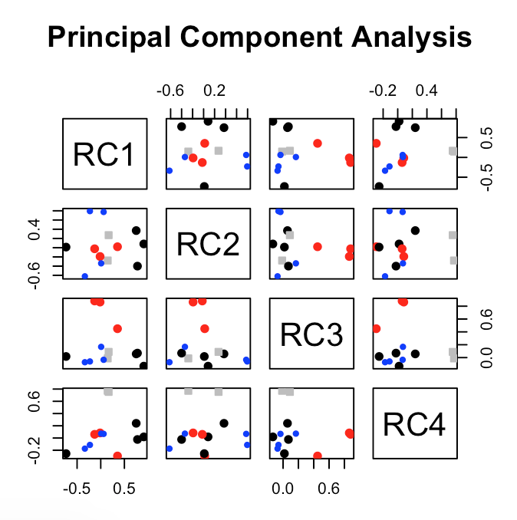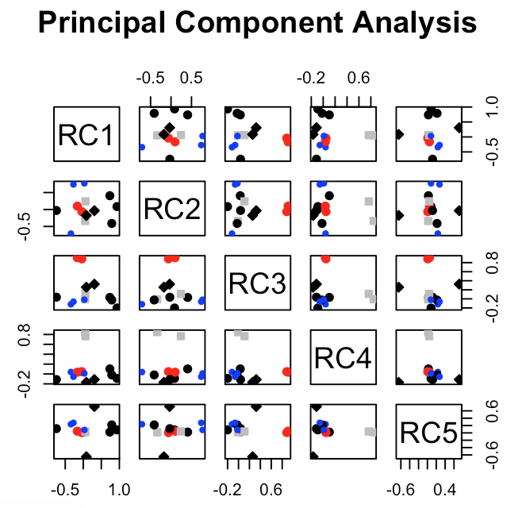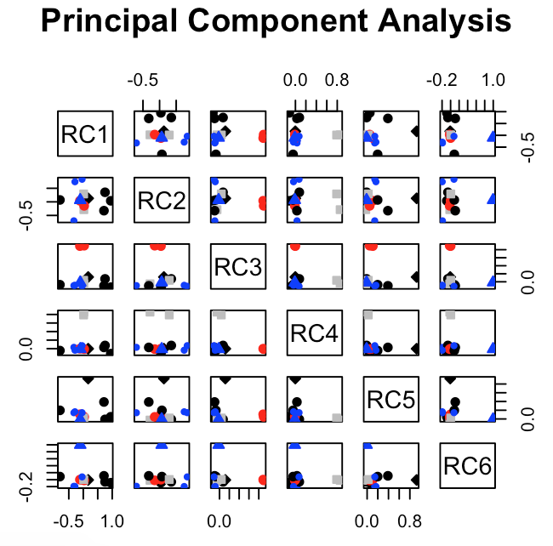

Then, we use 3d plotting function to show the differences in pc1, pc2 and pc3.

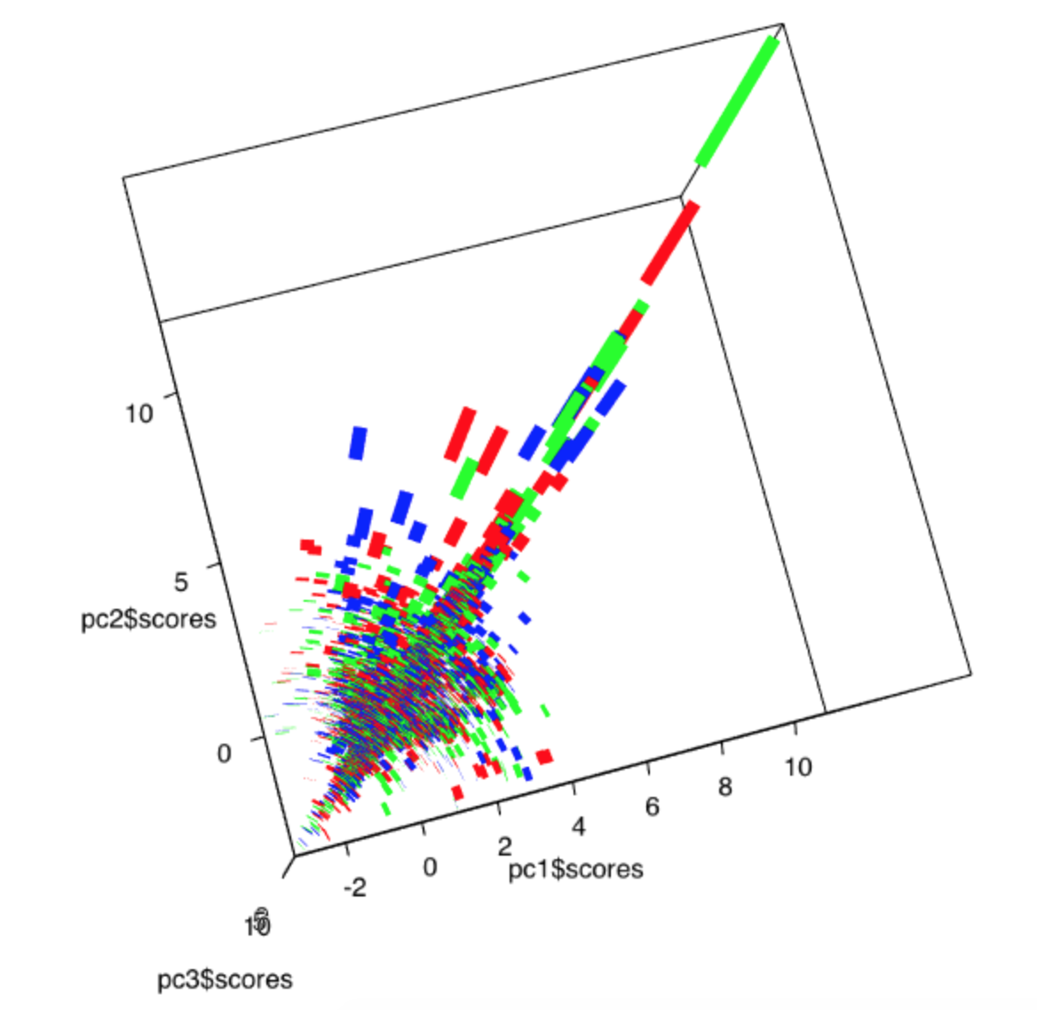

**3. Try plotting the data using several plotting functions to see the red wine and white wine data more.**

We use pairs (e.g., 2D plots) or 3 variables (3D plots) based on the packages.

The total packages we used are as follow:

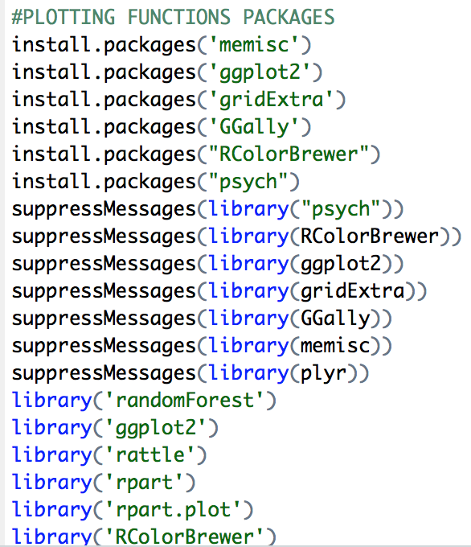

a) Let's learn these data a bit more, via a new variable - critic. This can reflect critic score, the red wine data can be separated into three groups according to their quality. Then we use bar plot method to show the data.

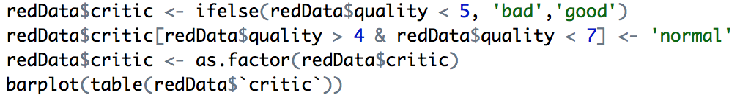

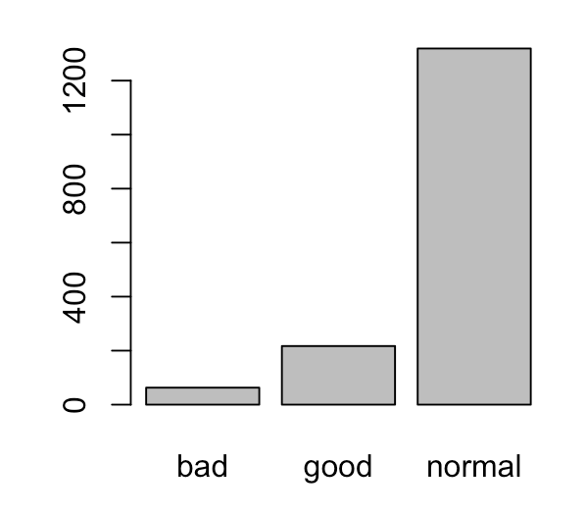

b) We randomly choose two attributes of the red wine and use barplot to get the results.

barplot(table(redData$`citric acid`),xlab="Distribution by citric acid")

barplot(table(redData$`pH`),xlab="Distribution by pH")

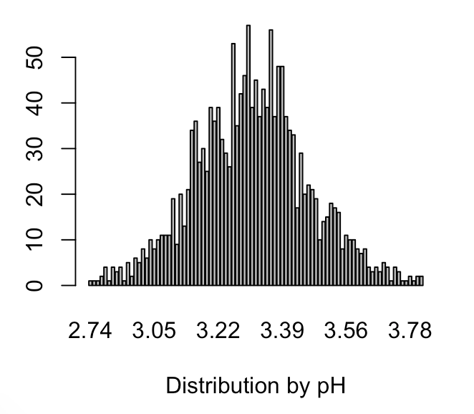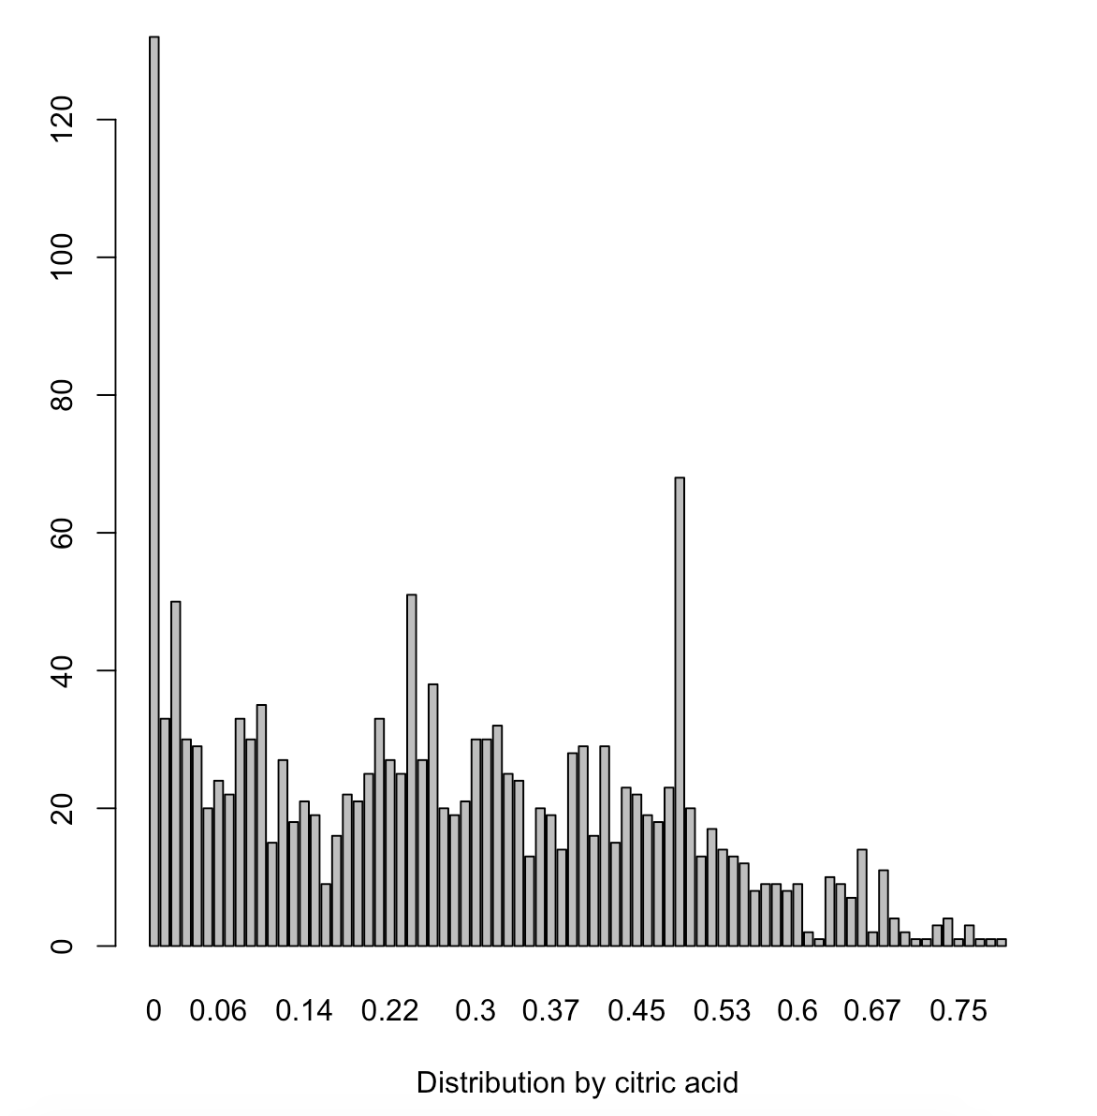

c) Compare red wine and white wine by using the same attribute of fixed acidity. Then, we plot the results.

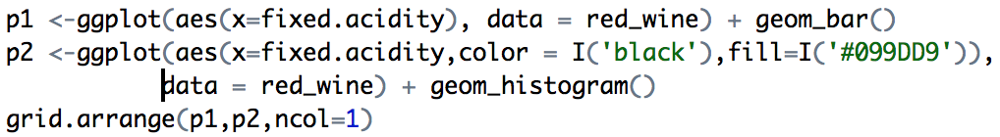

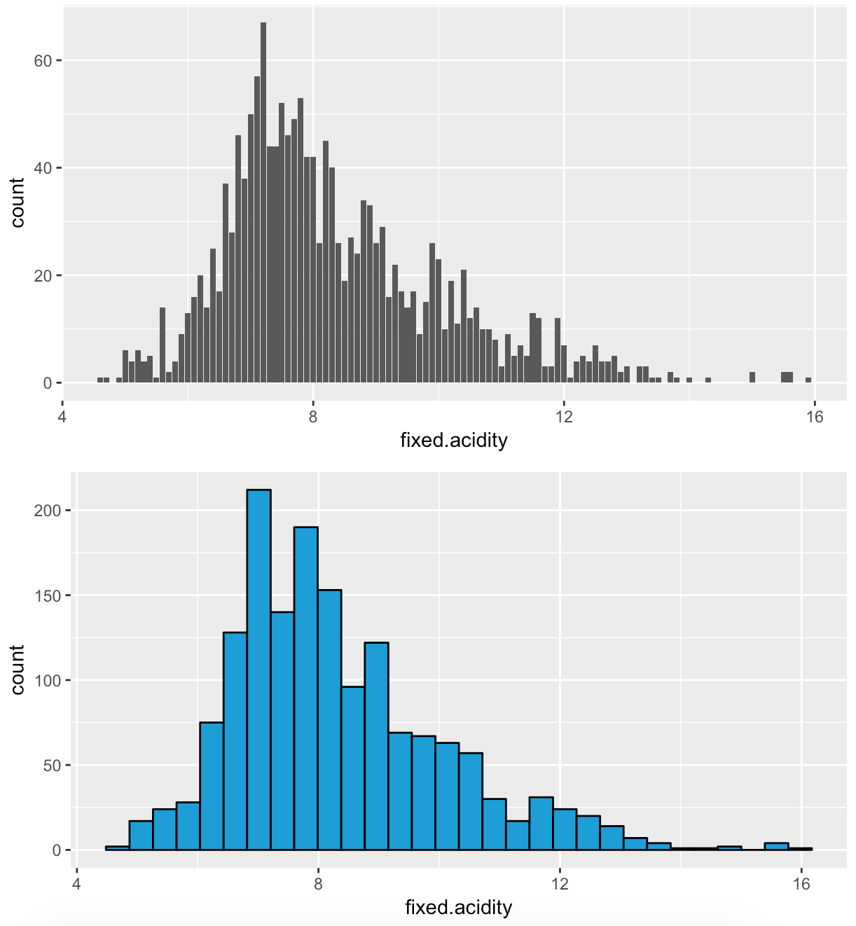

p3 <-ggplot(aes(x=redData$chlorides,color = I('#F5A9A9'),fill = I('#F5A9A9')),data = redData) + geom_histogram()

p4 <-ggplot(aes(x=whiteData$chlorides,color = I('#819FF7'),fill = I('#819FF7')),data = whiteData) + geom_histogram()

grid.arrange(p3,p4,ncol=1)

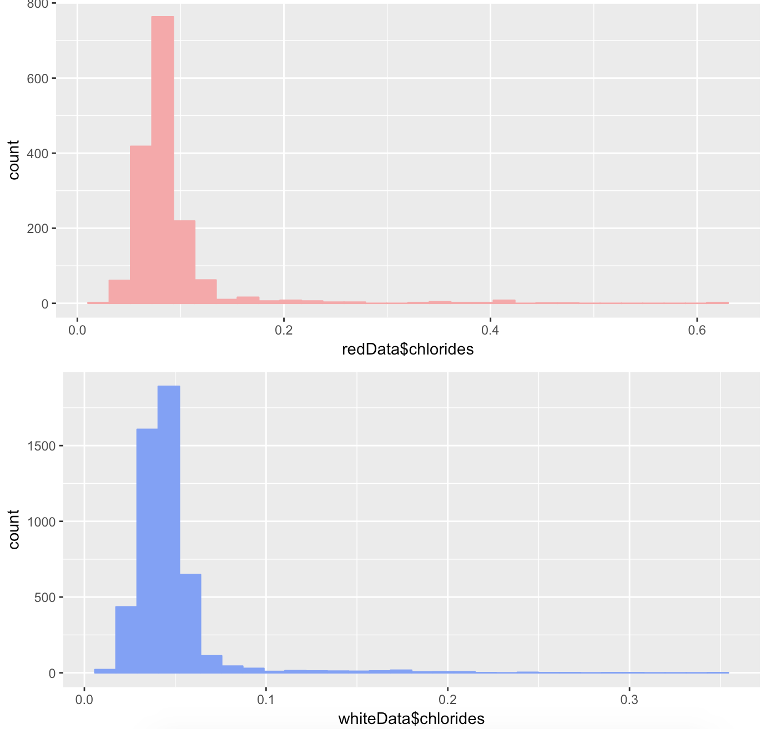

d) The value of citric acid ranges from 0 to 1. Most of the wines have zero citric acid .The second peak is at 0.48/0.49. The median is at 0.260, the 3rd quartile is at 0.420 and the max is at 1.000 which indicates the presence of the outliers.



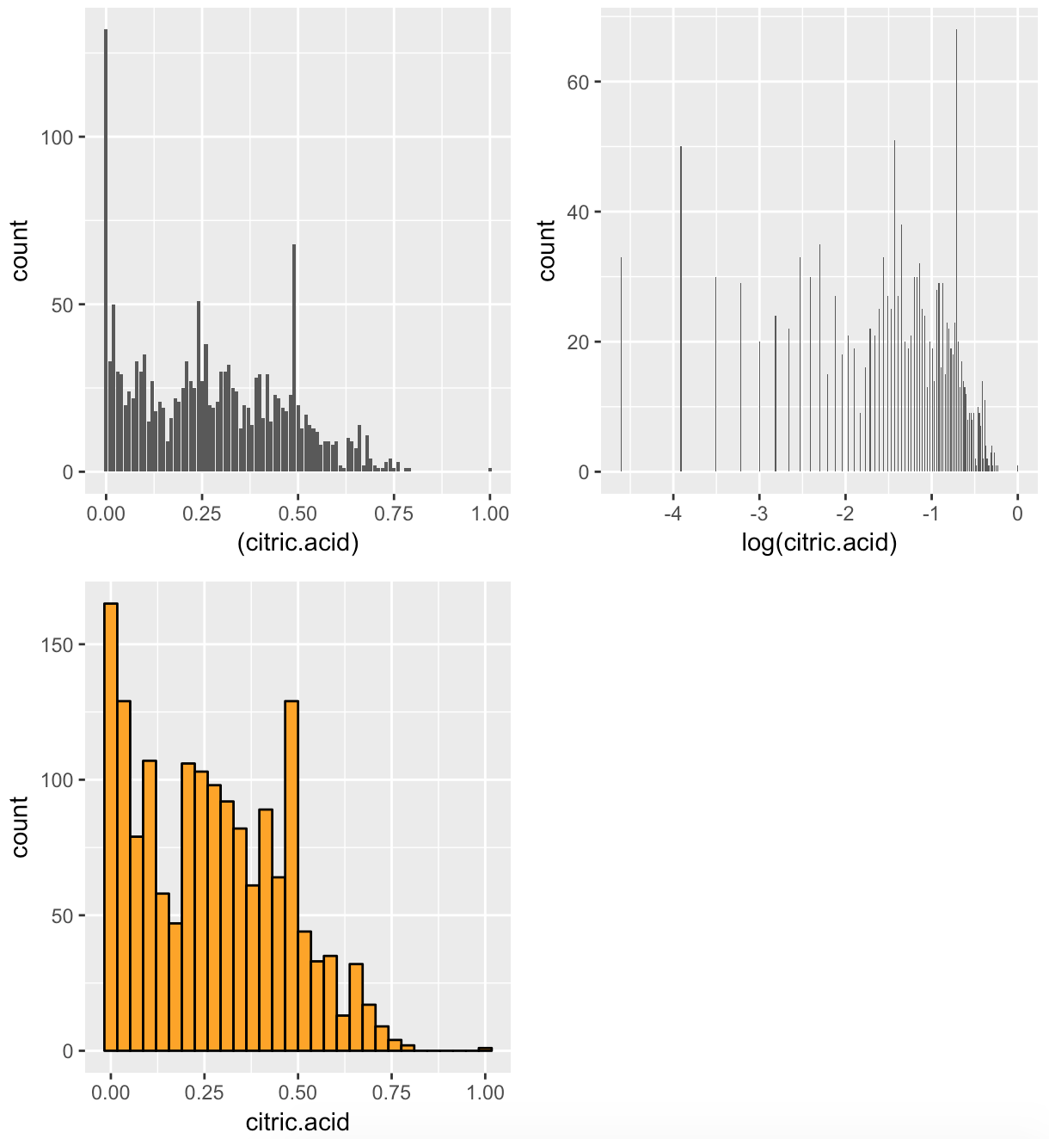

**3. Use 3D plotting method to show the multiple features of red wine and white wine.**

The left figure shows three features of red wine and the right figure shows same features of white one.

a)



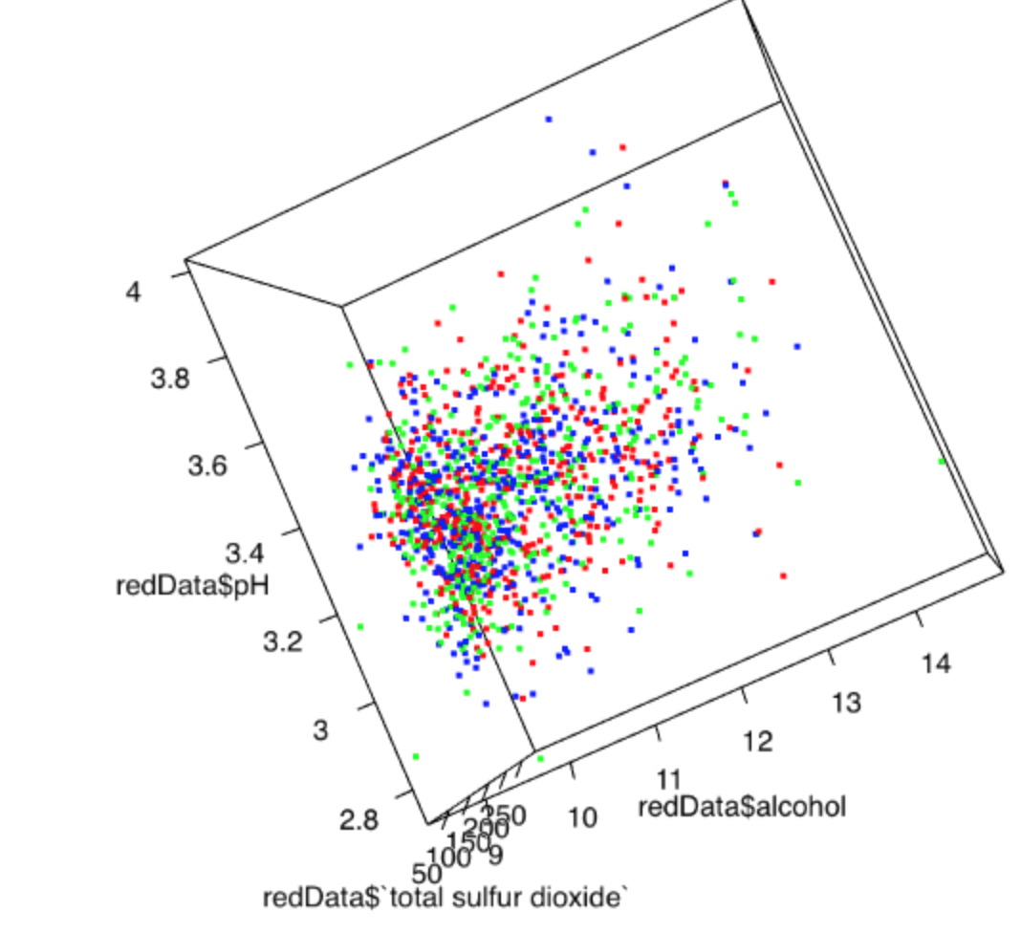

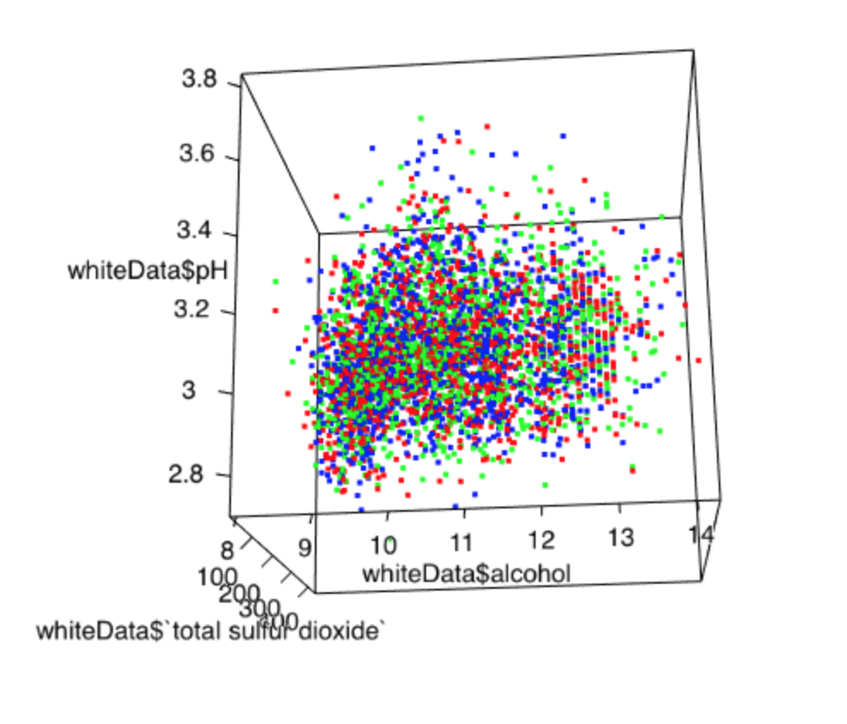

b)

**Part 2 Analysis of the various clustering techniques**

**1. Divide your data set into a training set and a test set. Use samples of 50-50, 60-40, and 70-30 for the training-test ratios**

a) Use sample.() to random choose elements. Use “replace=FALSE” to make sure no element be chosen twice.

Divide data based on 50:50 ratios:

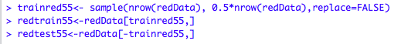

Then we get two data set after the division.

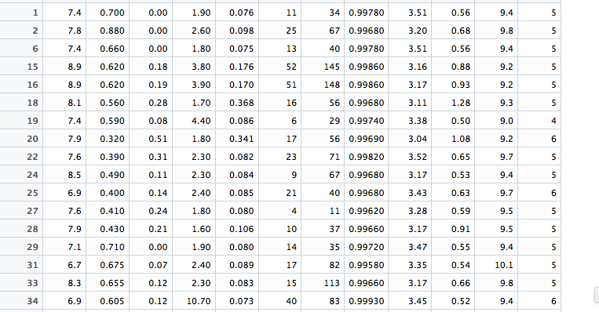

Train set for red wine when use 50:50 as training-test ratios

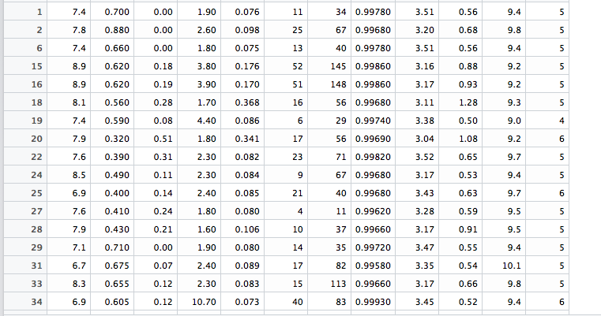

Test set for red wine when use 50:50 as training-test ratios

c) We get all data set based on different training-test ratios by changing the parameters in sample( ).

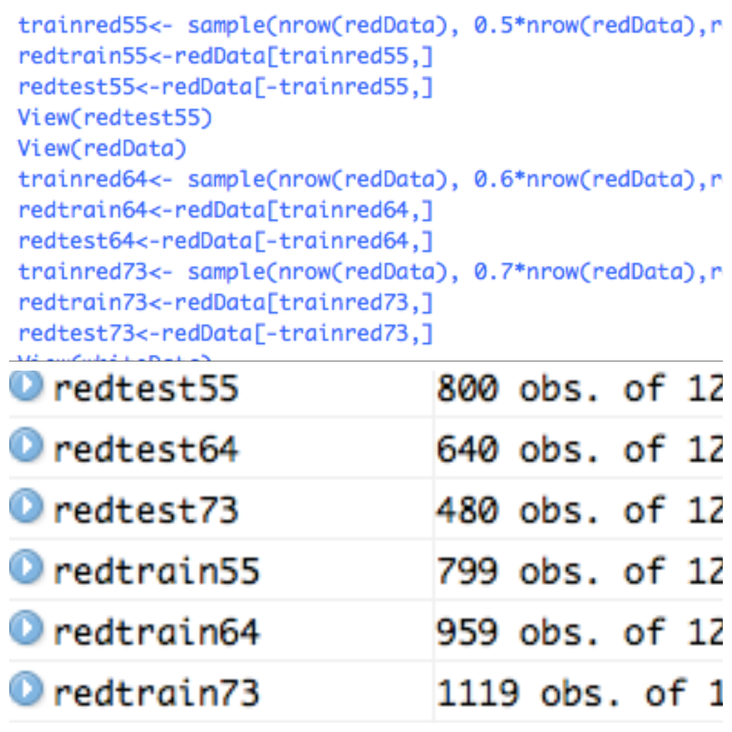

**2. Use various clustering techniques such as k-means, k nearest neighbors**

From this correlation plot built from creating correlation table for our attributes, we can see that the important variables in row 1 are: fixed acid, critic acid, pH and density.

R code:

library(corrplot)

corNumTable<-cor(redData)

corrplot(corNumTable)

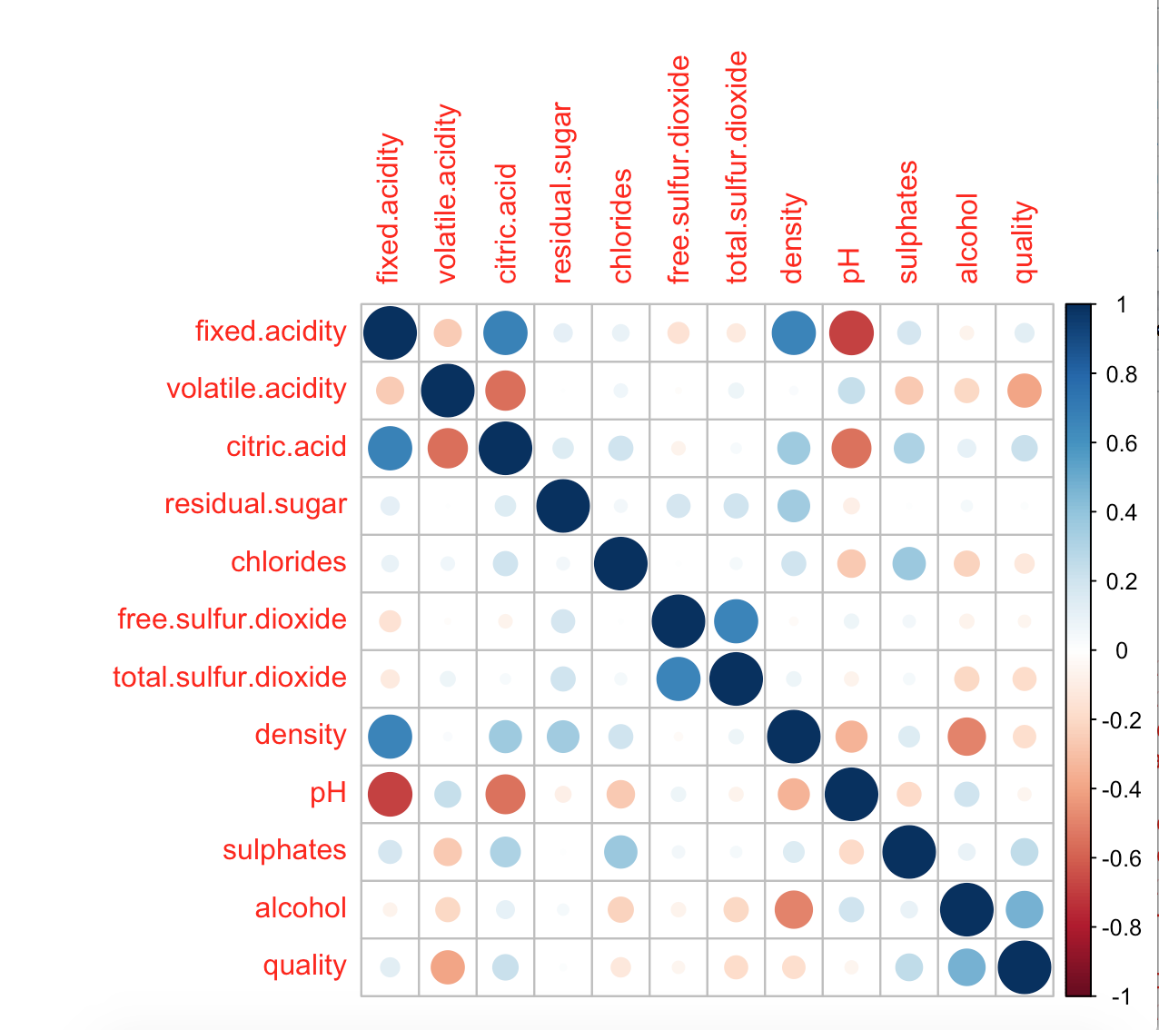

a) K means

main R code:

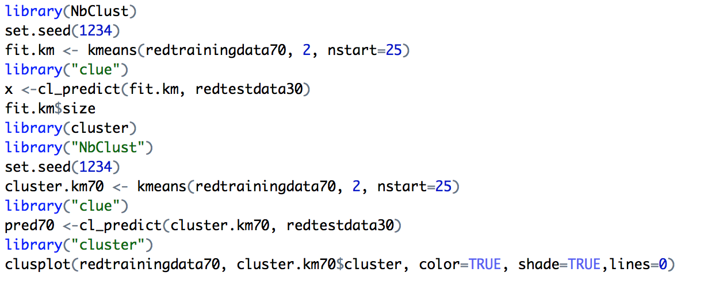

Apply k-means for 2 clusters, 3 clusters, 5 clusters and 7 clusters for each division:

N=2:

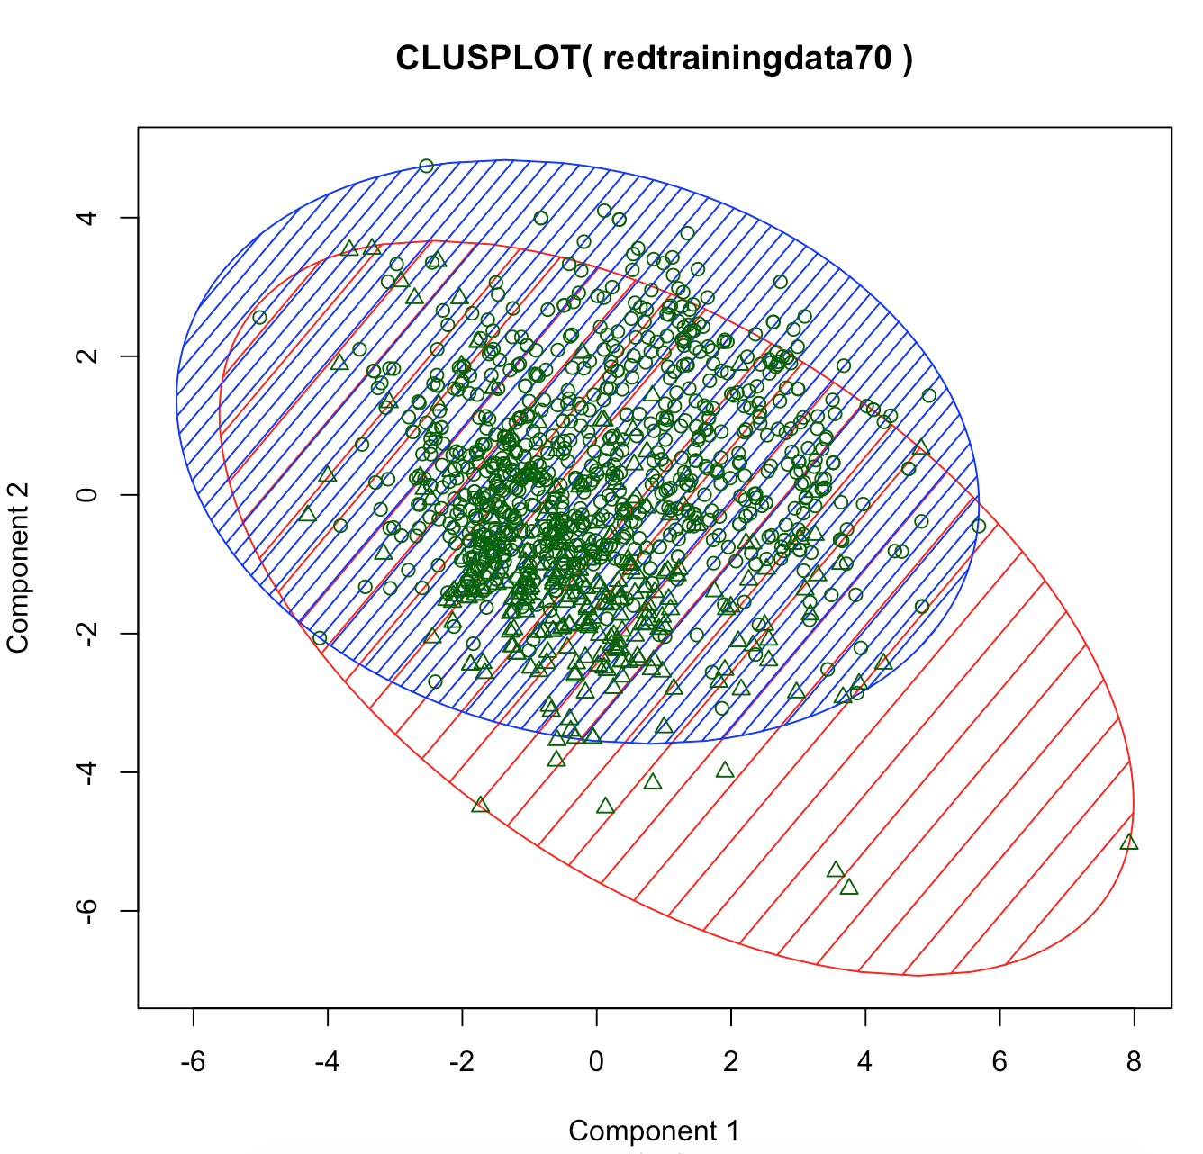

N=3

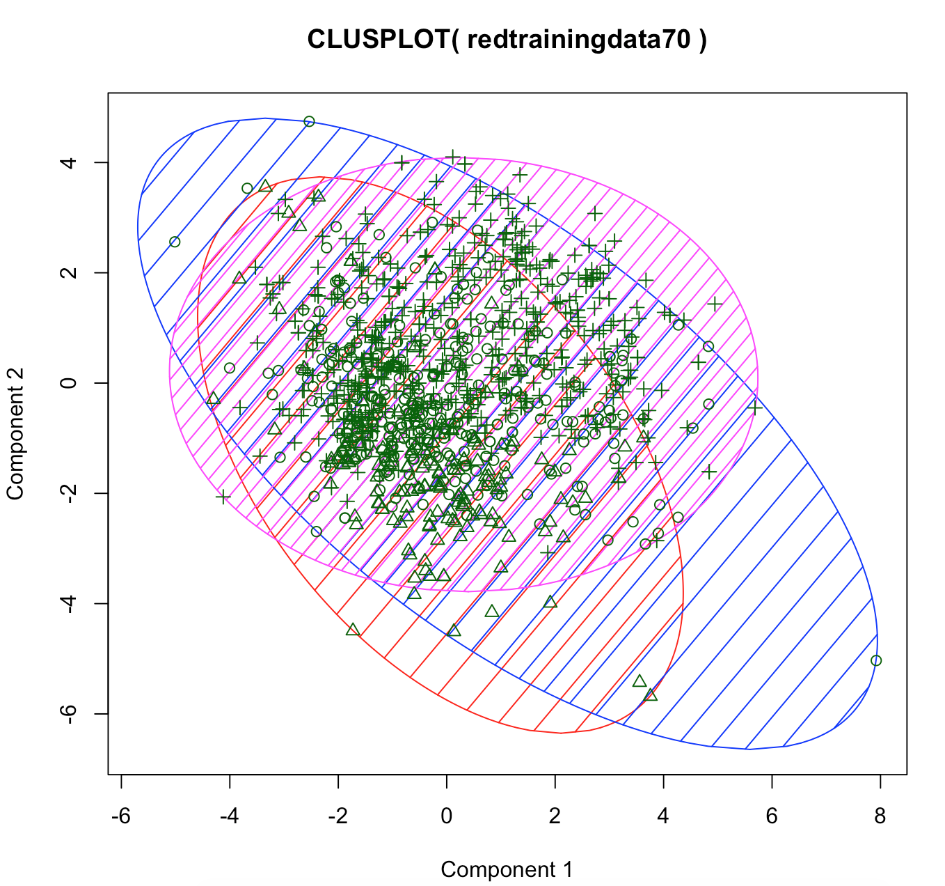

N=5

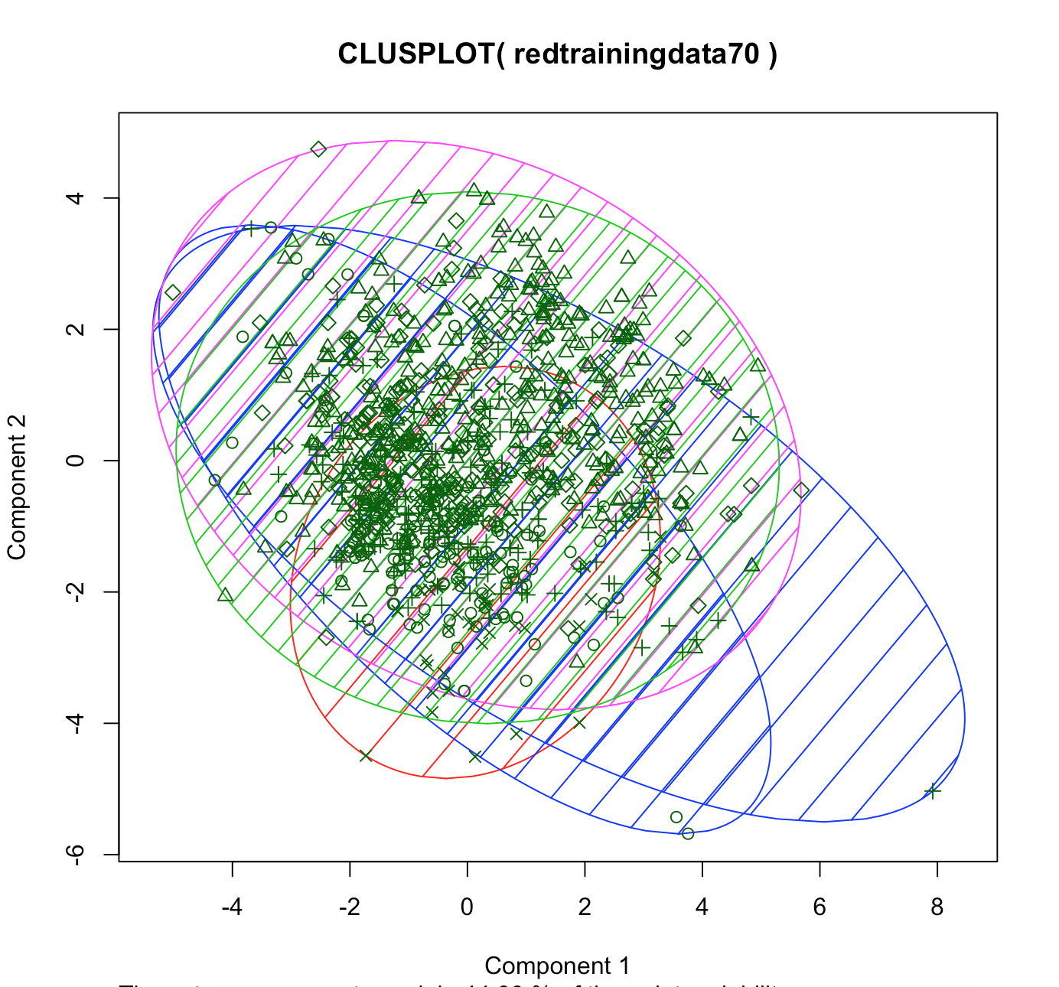

N=7

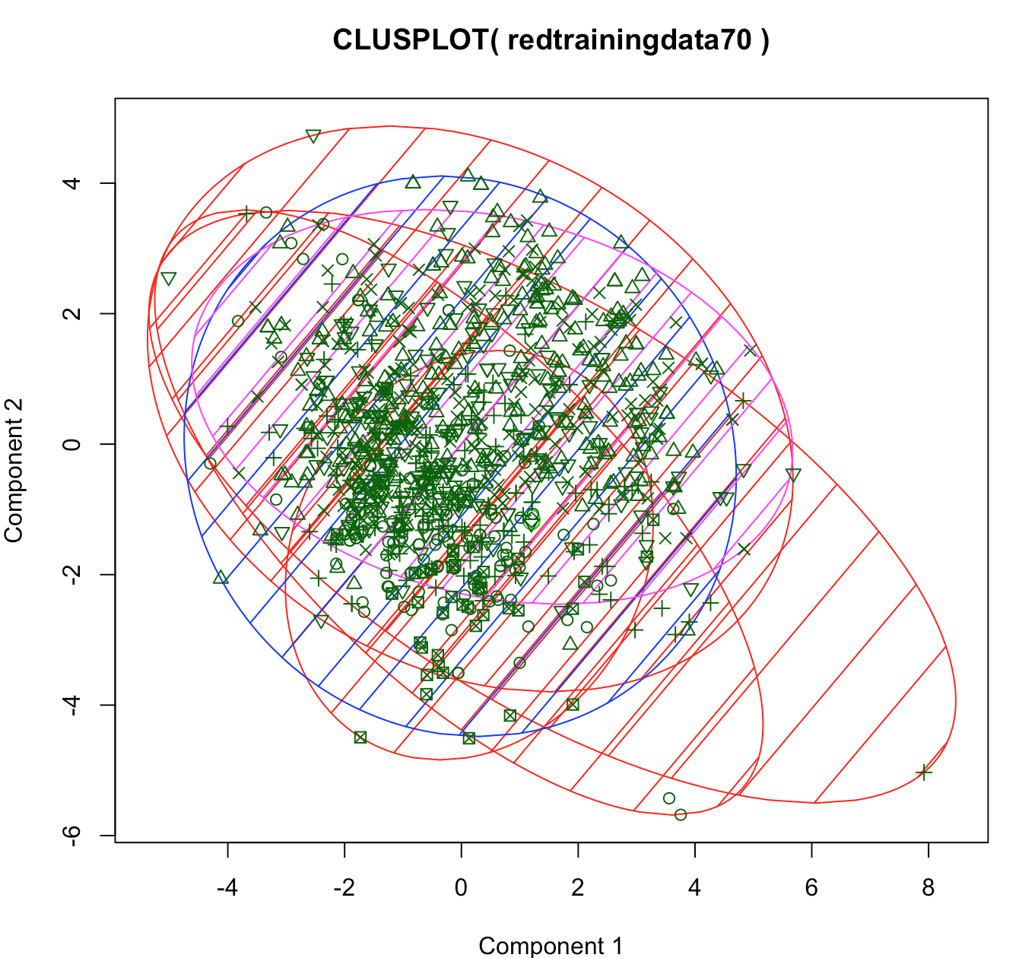

b) K nearest neighbours

First we apply a principal component analysis(PCA) on the input data:

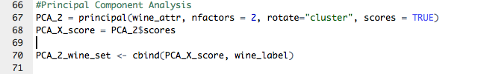

The knn function are as follows:

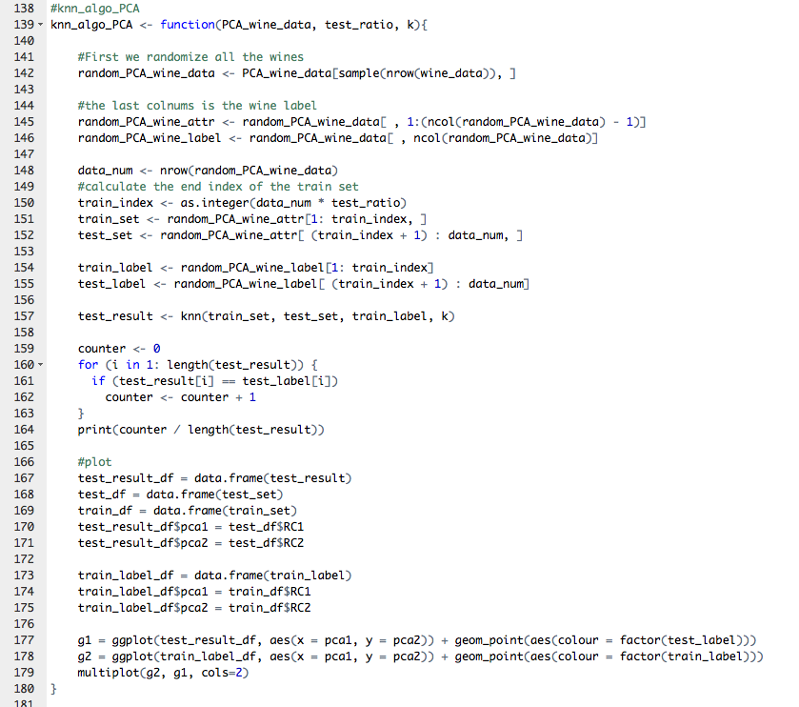

As the requirement of this project, we have to use different train-test ration the N to run the algorithms.

knn_algo_PCA(PCA_2_wine_set, 0.5, 3)

When training set and a test set is 50-50, and the sample is clustered into 3 class:

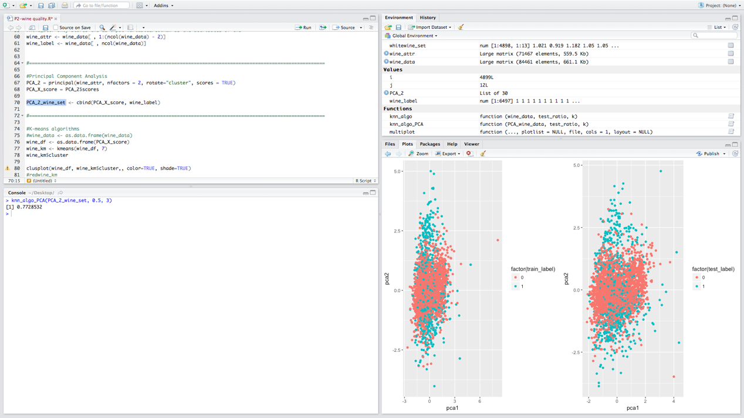

knn_algo_PCA(PCA_2_wine_set, 0.5, 5)

When training set and a test set is 50-50, and the sample is clustered into 5 class:

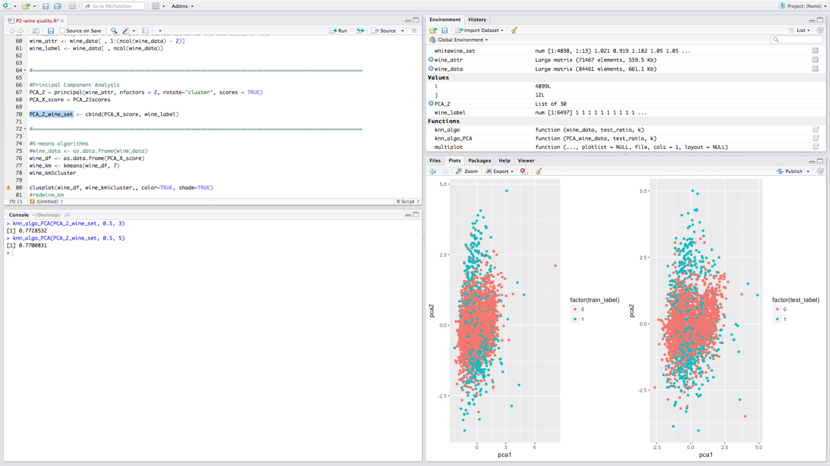

knn_algo_PCA(PCA_2_wine_set, 0.5, 7)

When training set and a test set is 50-50, and the sample is clustered into 7 class:

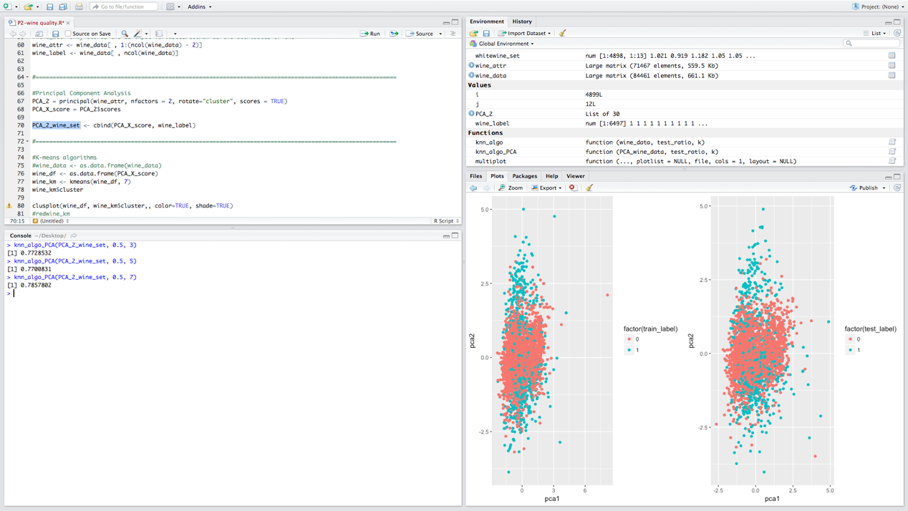

knn_algo_PCA(PCA_2_wine_set, 0.6, 3)

When training set and a test set is 60-40, and the sample is clustered into 3 class:

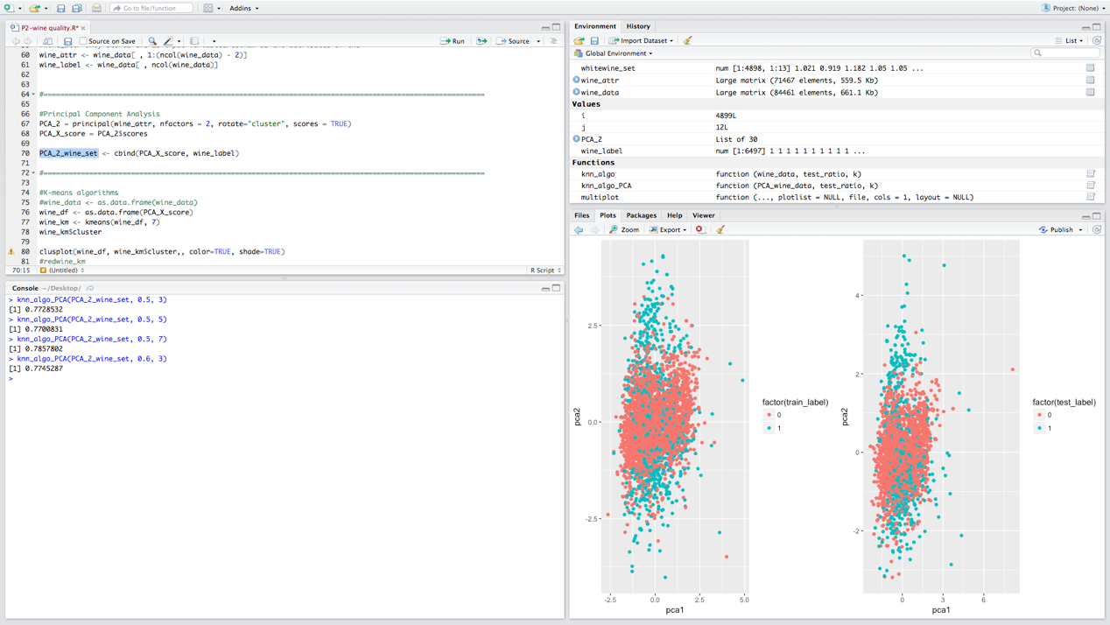

knn_algo_PCA(PCA_2_wine_set, 0.6, 5)

When training set and a test set is 60-40, and the sample is clustered into 5 class:

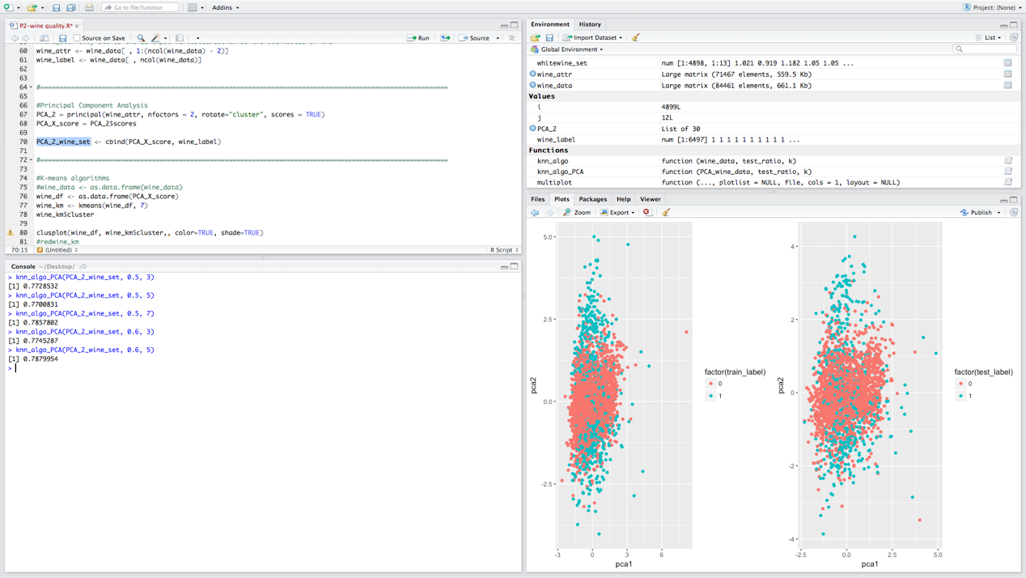

knn_algo_PCA(PCA_2_wine_set, 0.6, 7)

When training set and a test set is 60-40, and the sample is clustered into 7 class: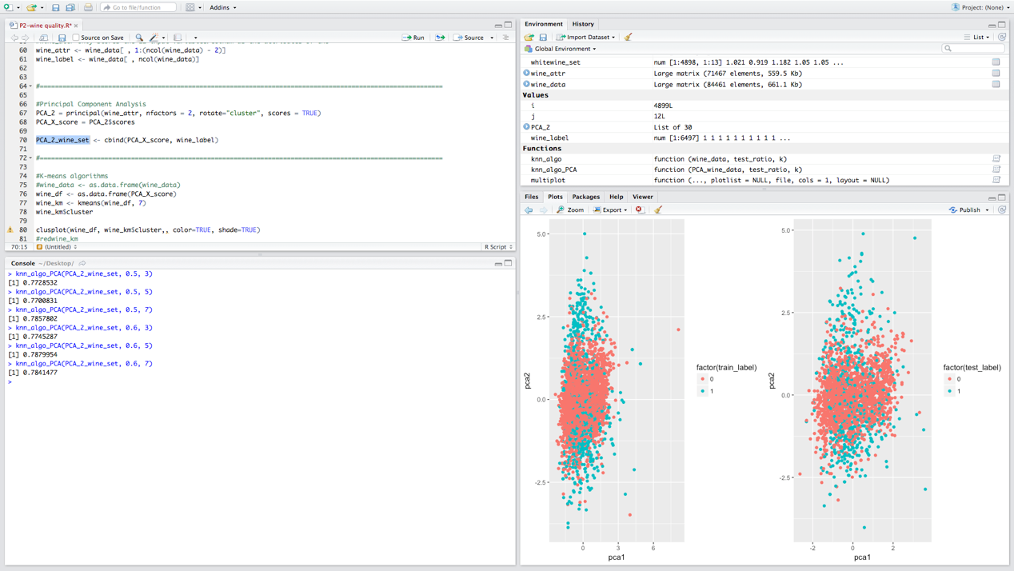

knn_algo_PCA(PCA_2_wine_set, 0.7, 3)

When training set and a test set is 70-30, and the sample is clustered into 3 class:

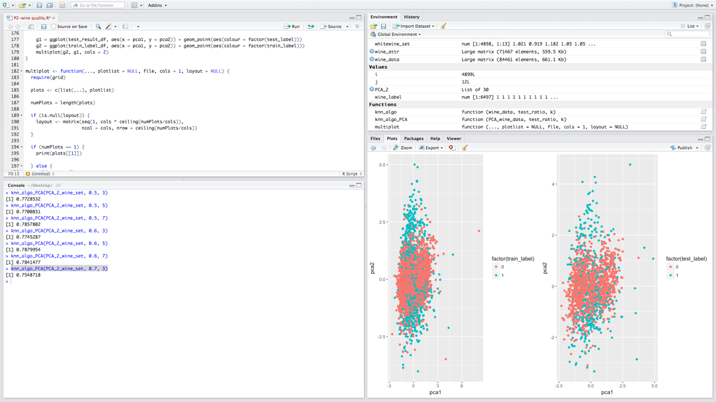

knn_algo_PCA(PCA_2_wine_set, 0.7, 5)

When training set and a test set is 70-30, and the sample is clustered into 5 class:

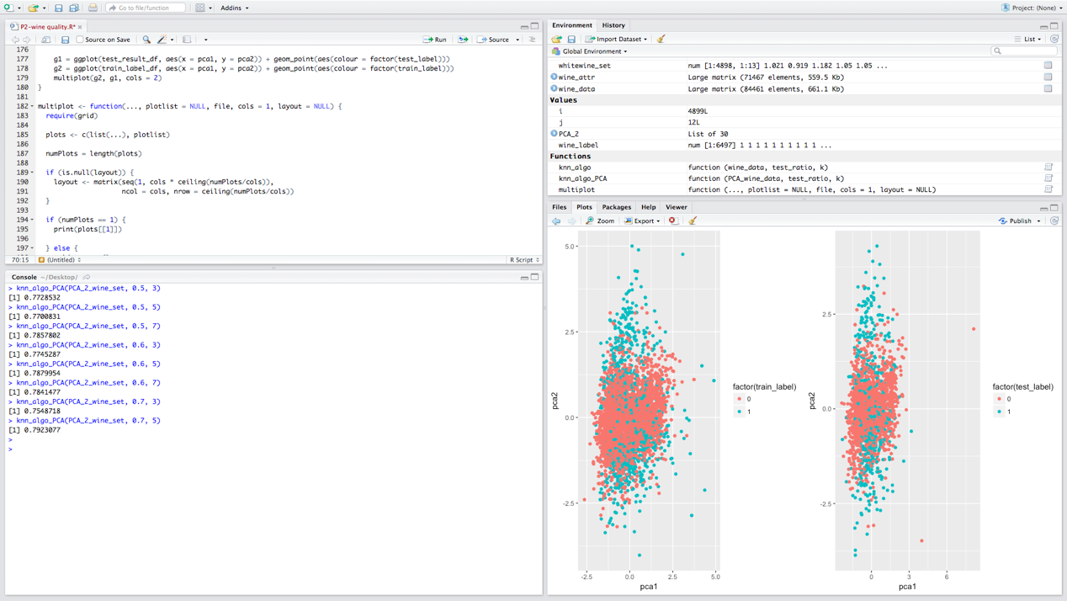

knn_algo_PCA(PCA_2_wine_set, 0.7, 7)

When training set and a test set is 70-30, and the sample is clustered into 7 class:

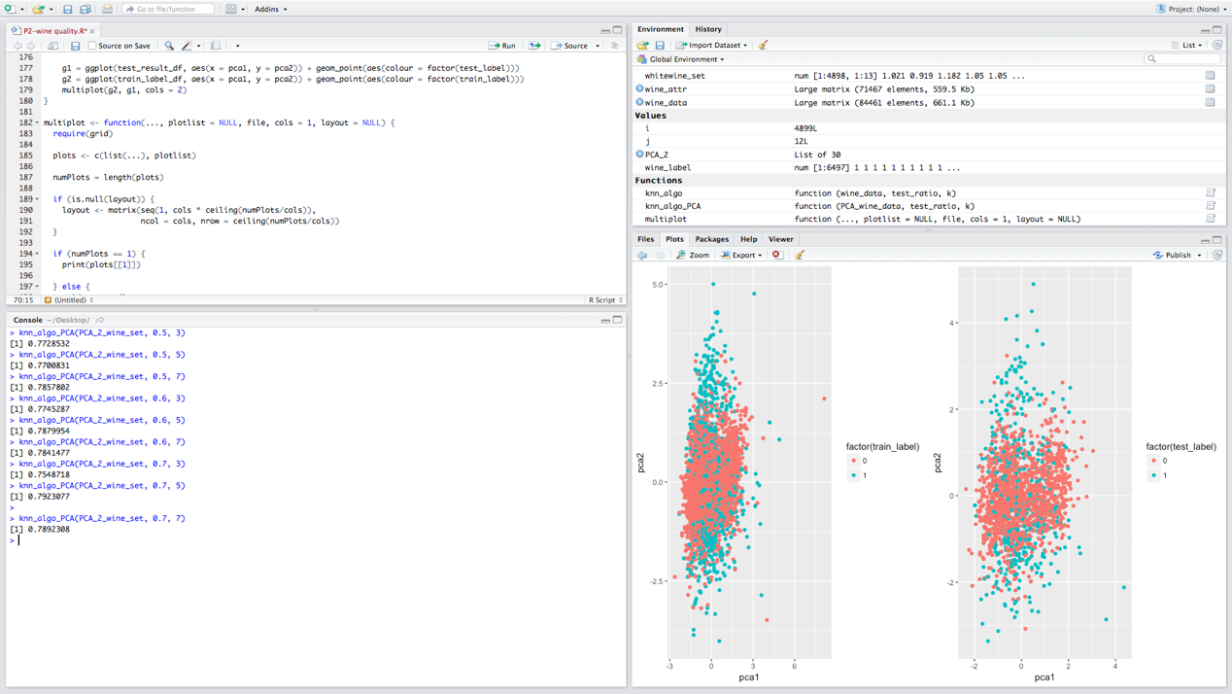

The accuracies are as follows:

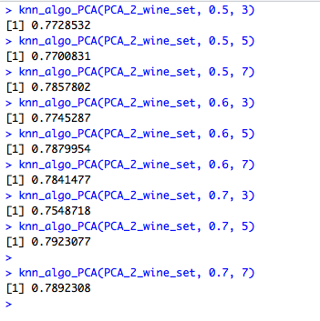

put all these results in a table:

|  |  |  |  |
| --- | --- | --- | --- |
|  | 50-50 | 60-40 | 70-30 |
| N=3 | 0.7728532 | 0.7745287 | 0.7548718 |
| N=5 | 0.7700831 | 0.7879954 | 0.7923077 |
| N=7 | 0.7857802 | 0.7841477 | 0.7892308 |

If we do not make principle component analysis before we apply the data on the knn function, the results will be much better.

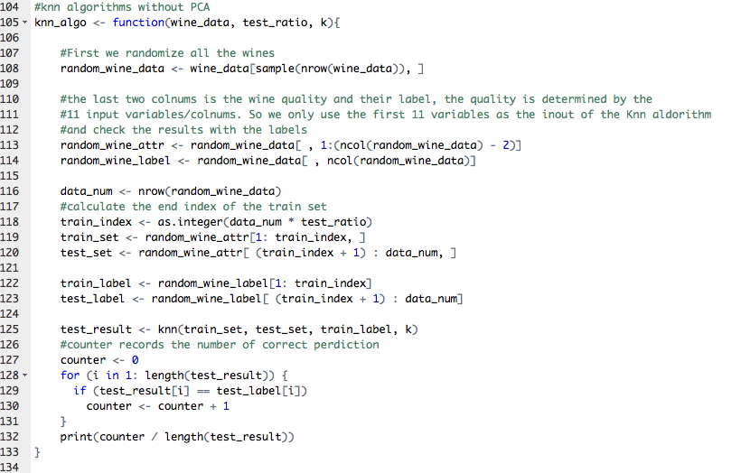

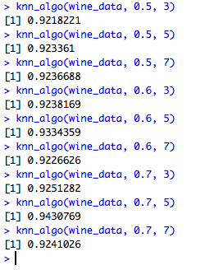

|  |  |  |  |
| --- | --- | --- | --- |
|  | 50-50 | 60-40 | 70-30 |
| N=3 | 0.9218221 | 0.9238169 | 0.9251282 |
| N=5 | 0.923361 | 0.9334359 | 0.9430769 |
| N=7 | 0.9236688 | 0.9226626 | 0.9241026 |

c) Hierarchical Clustering

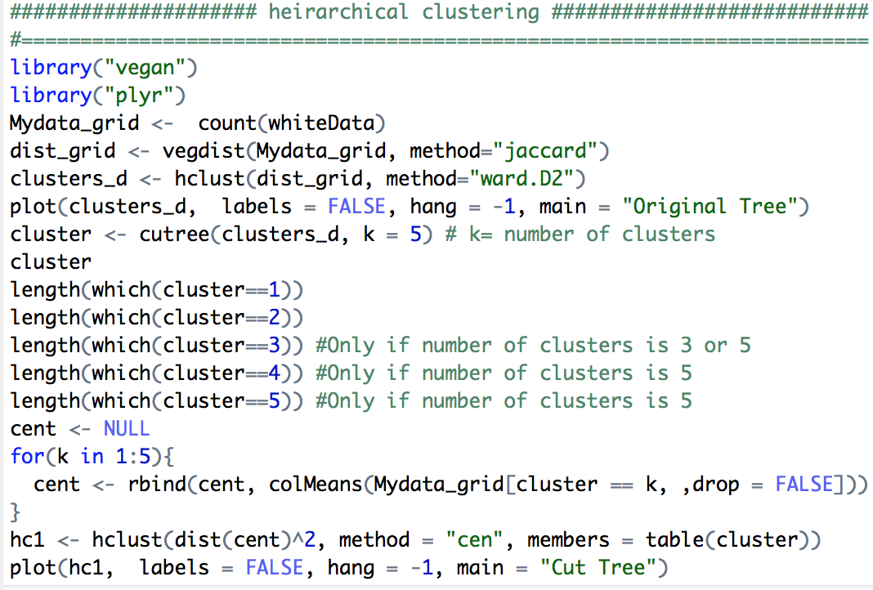

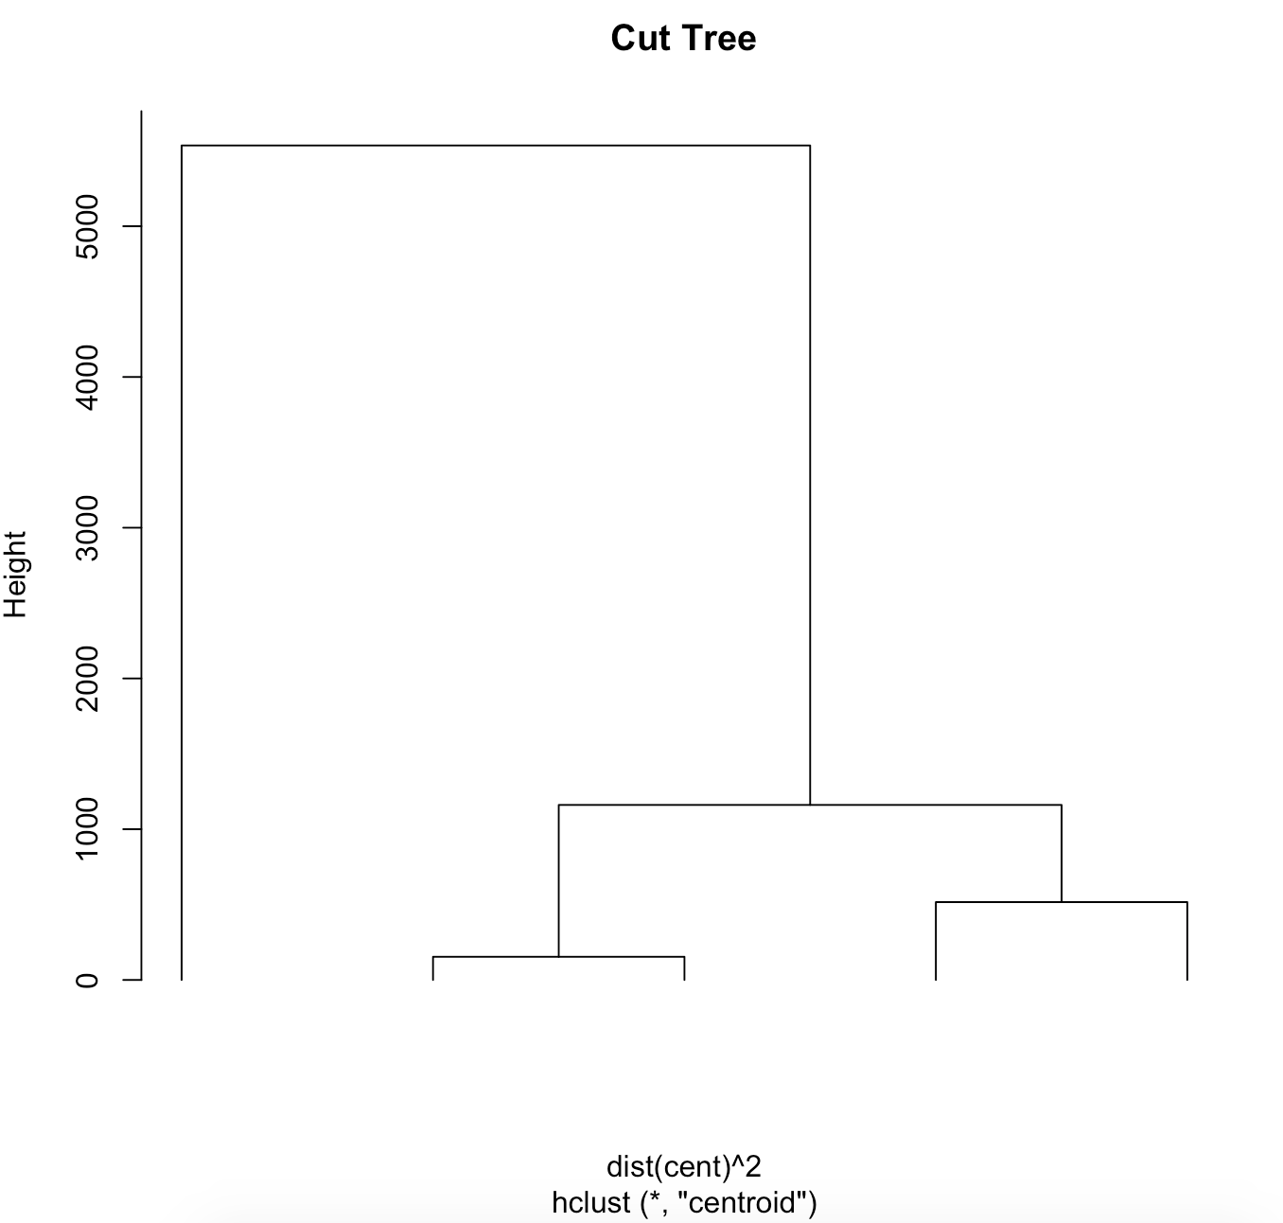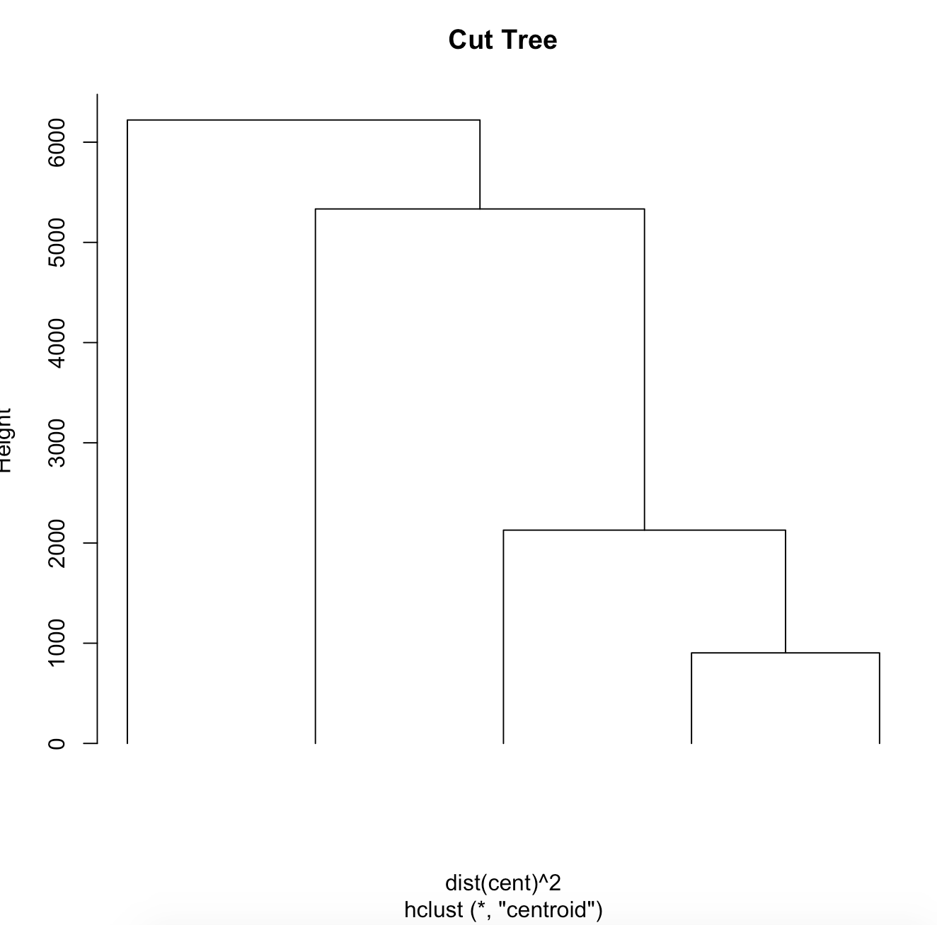

d) using pvclust

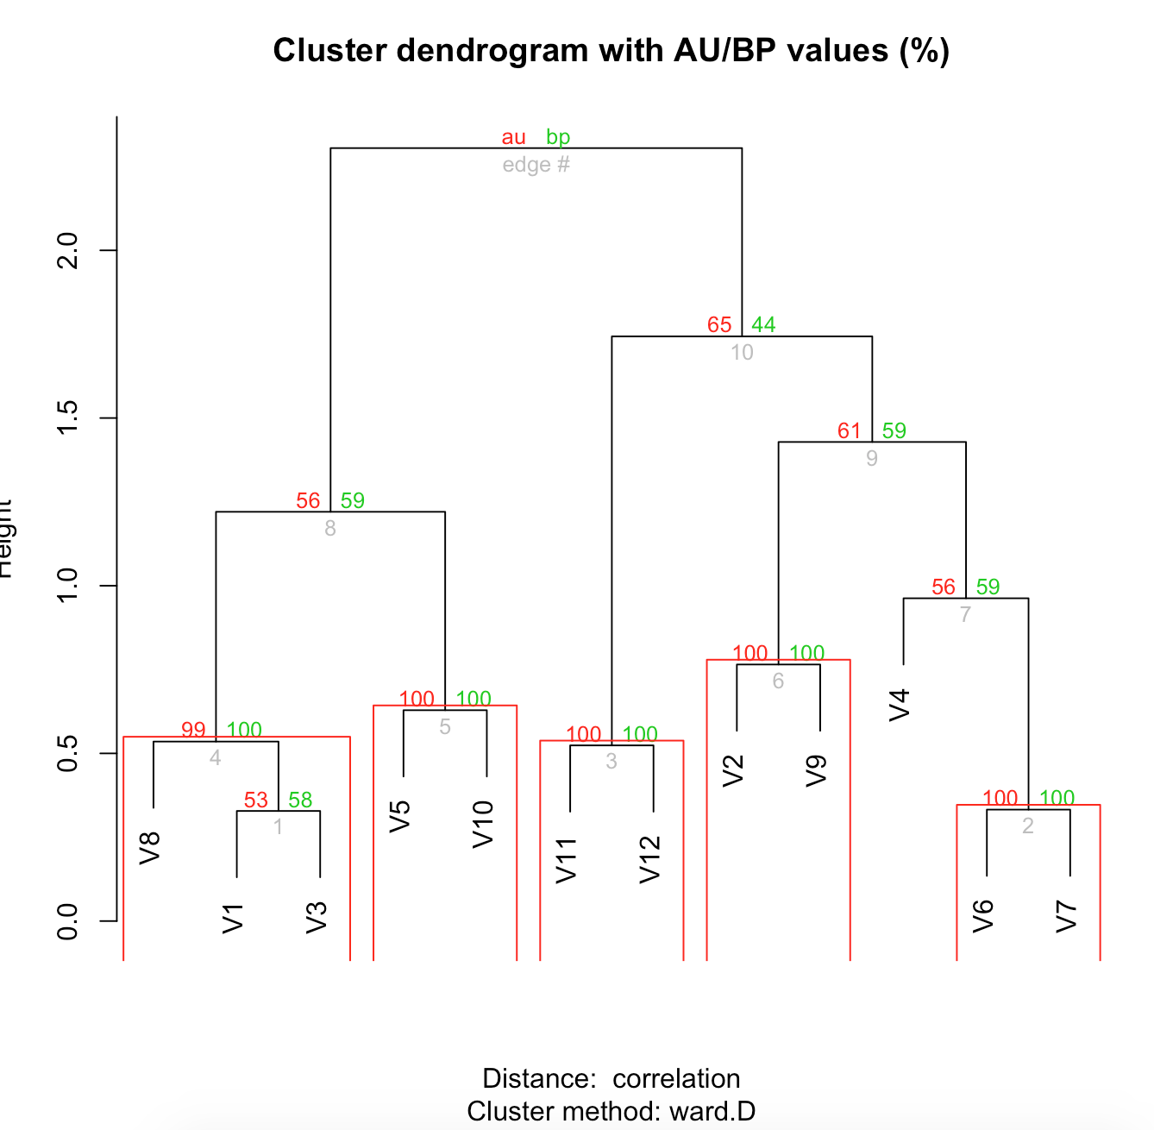

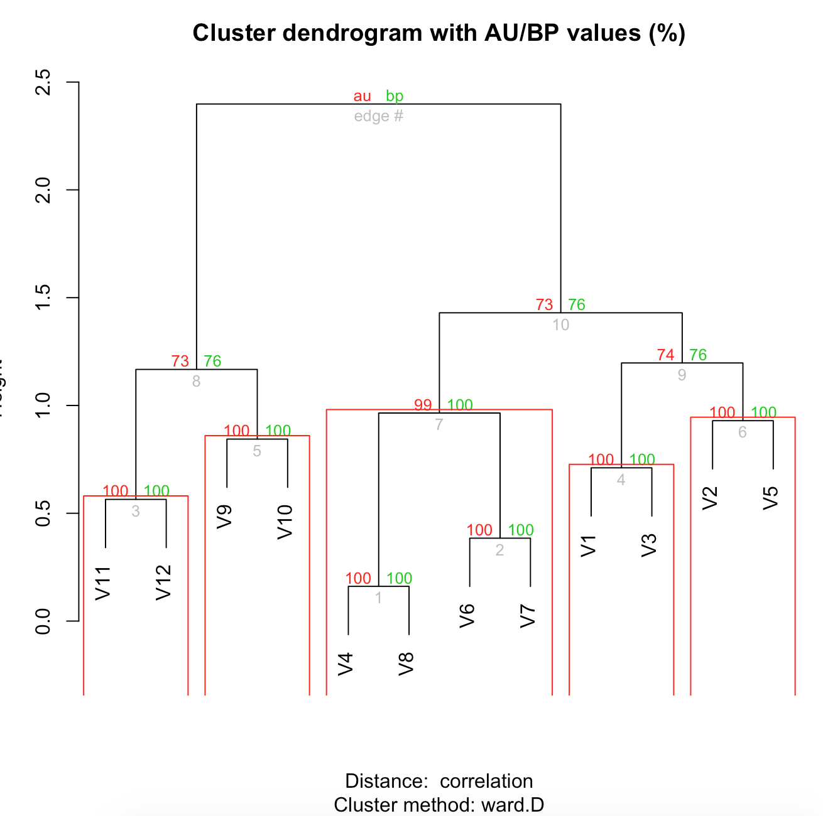

**3. Results analysis**

A) Use lm()function with all attributes I.Use lm() function to create two regression model.

Use summary() to check the R-squared and p-value.

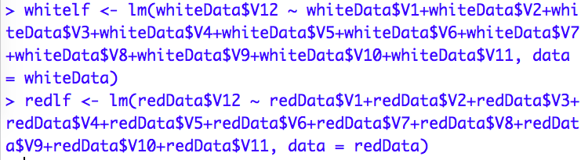 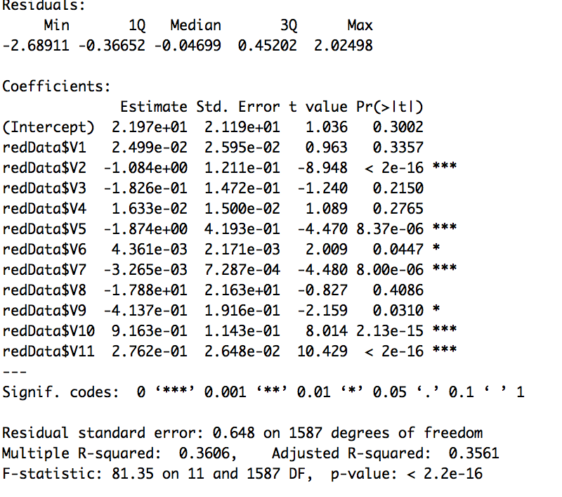

Summary of redData linear model

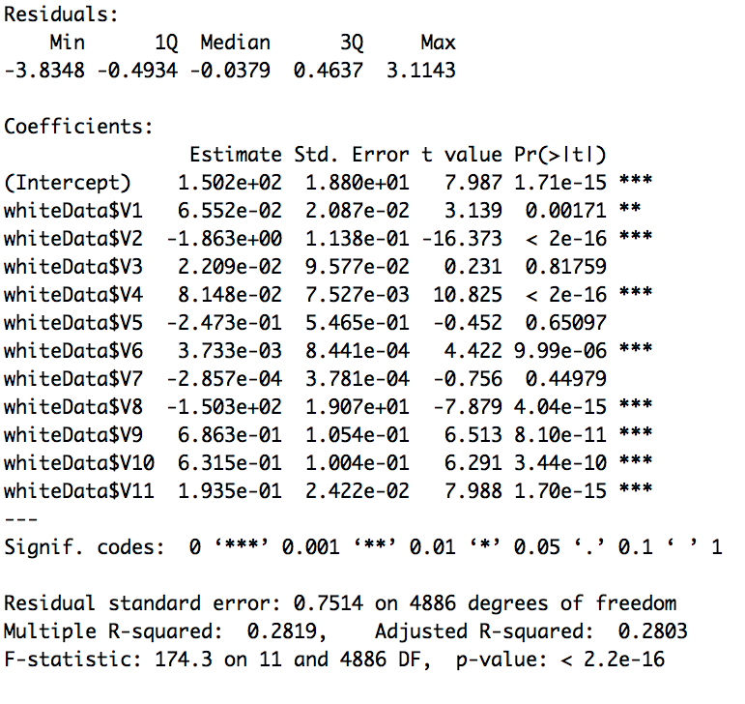

Summary of whiteData linear model Both p-value significantly less than 0.05. So we can say the null hypothesis is denied. The R-squared are both about 0.3. Use plot() to check Residuals vs Fitted, Nomal Q-Q, Scale-Location and Residuals vs Leverage

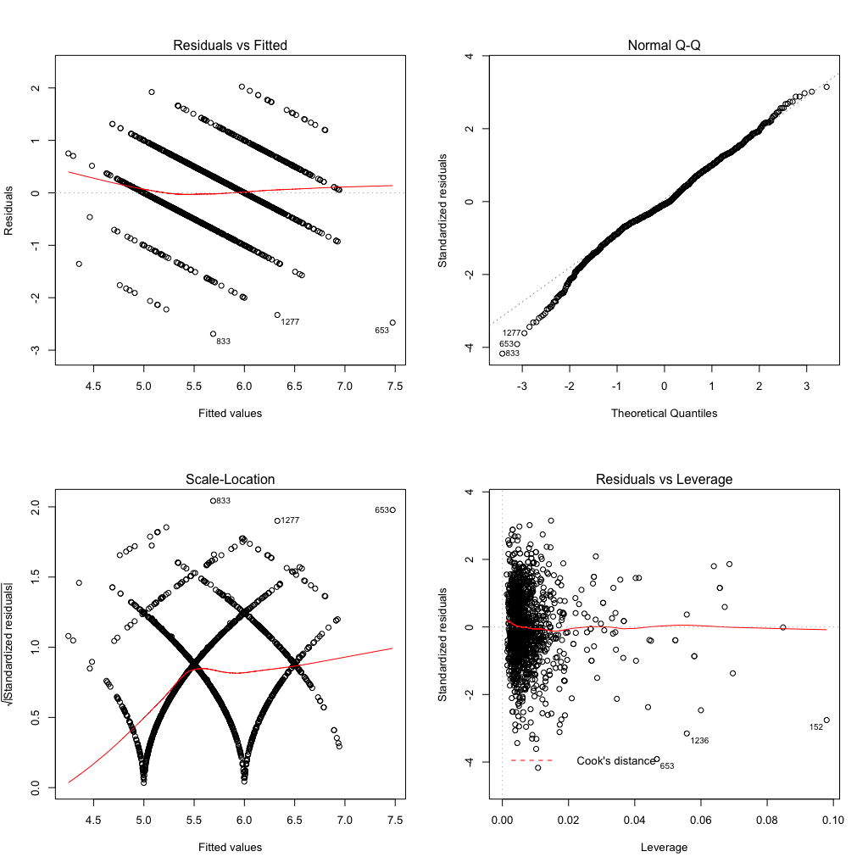

Images of redlf

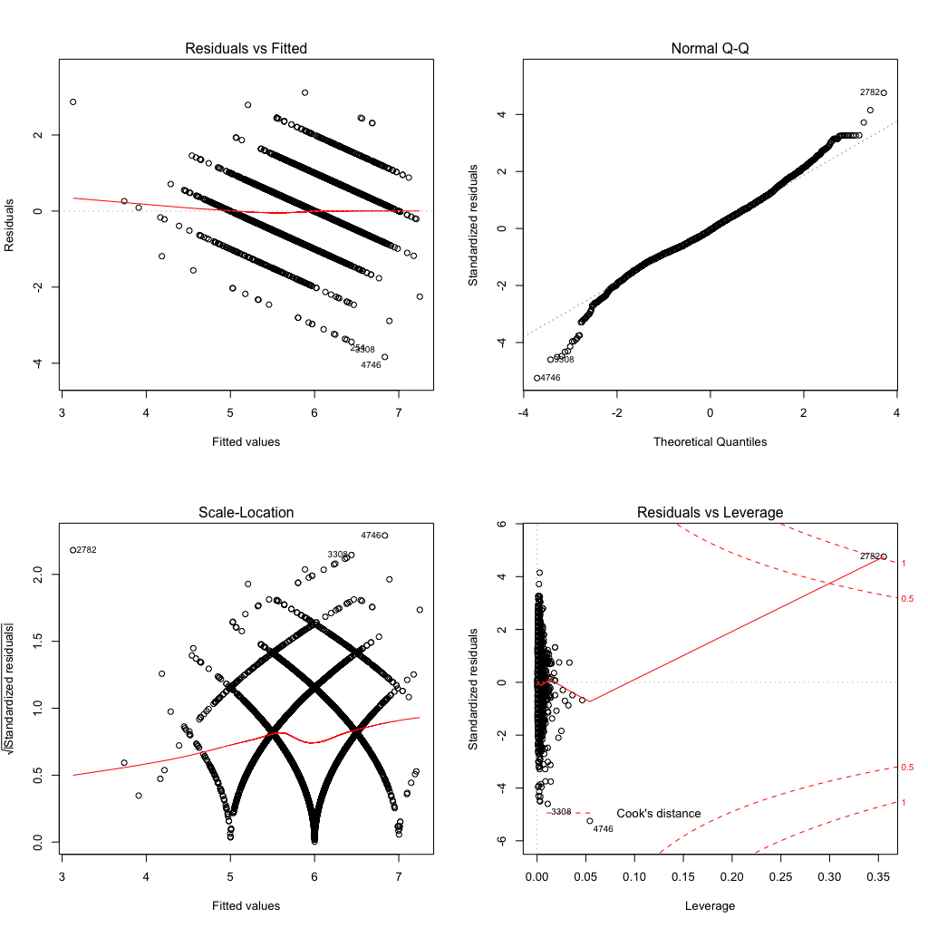

Image of whitelf What's more. We can use function outliertest from package car to find the most extreme observation.

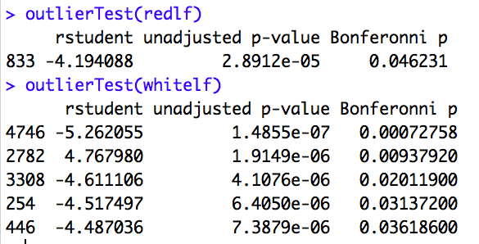

B) Linear fits with adjusted attributes I. Smoothing the quality attribute. We notice that R-squared of white wine is smaller, so we take some method in order to better results. Fisrt we smoothing the quality parameters.

  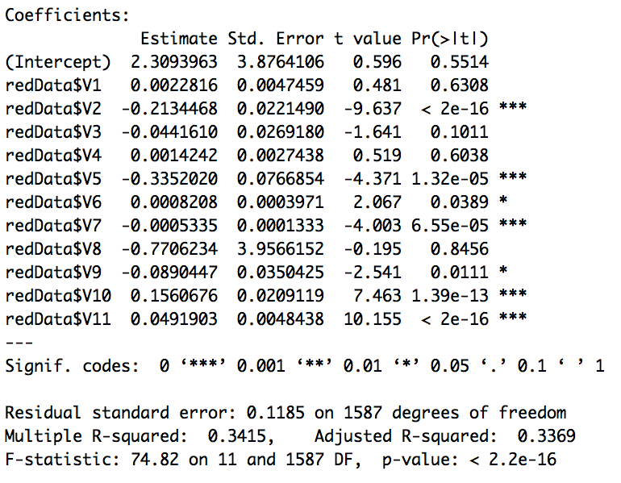

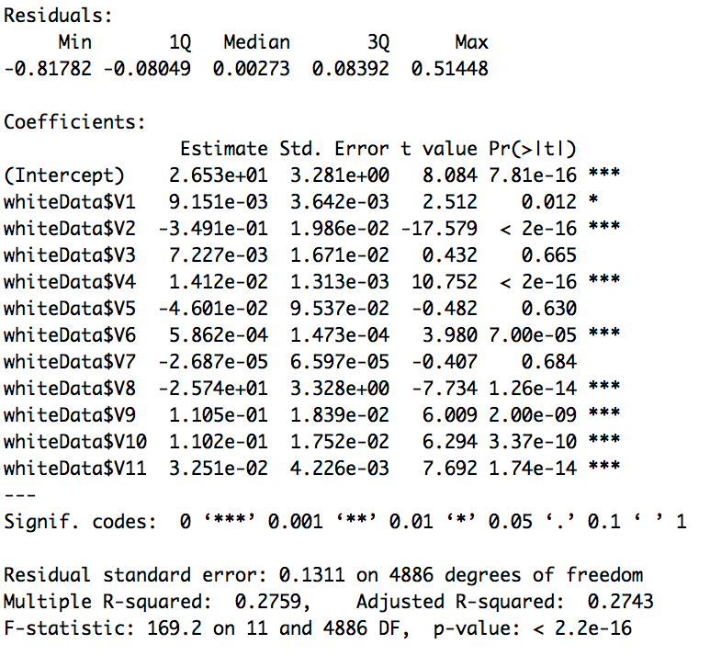 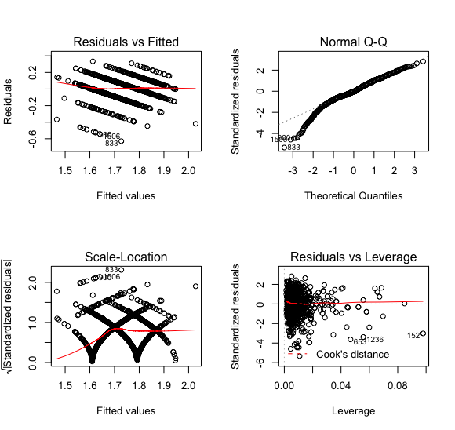

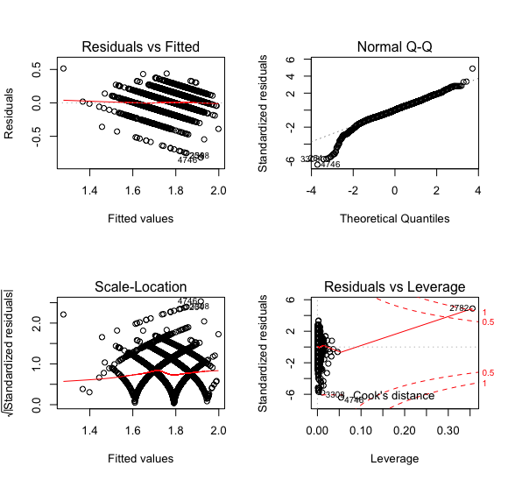

After smoothing, R-squared slightly reduced and p-value is still significantly small. II.Extend the quality attribute Second, we use a Square quality as a new parameter.

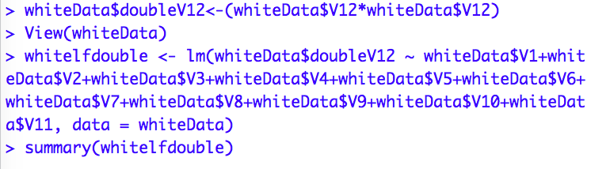

Then, check the R-squared and p-value.

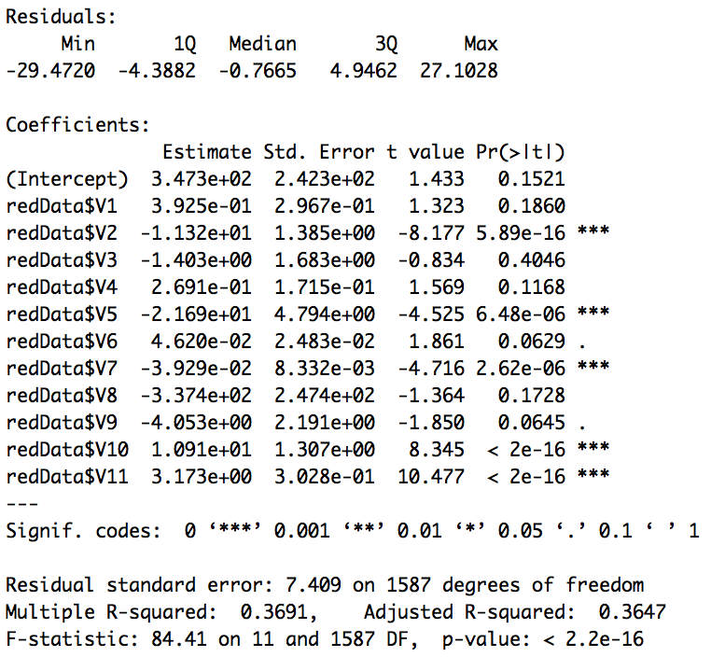

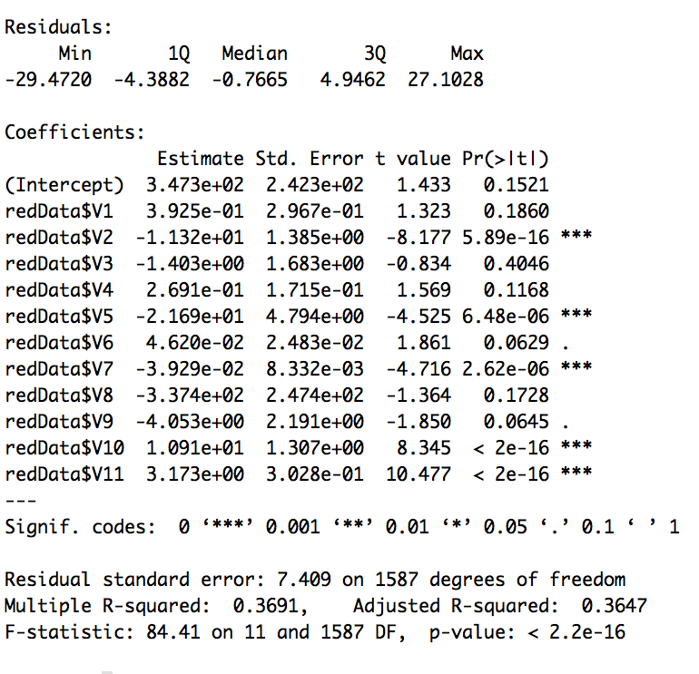

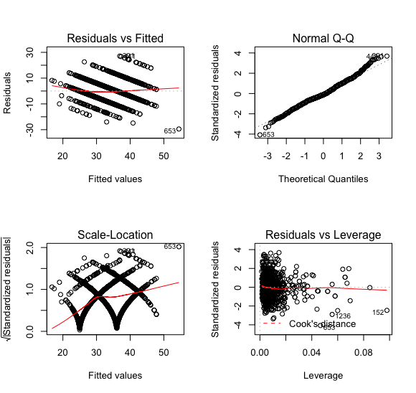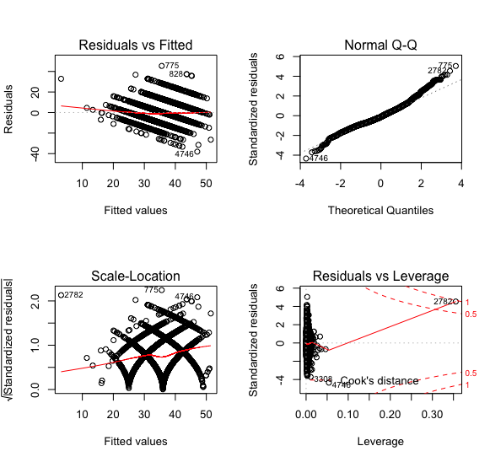

Similar to smoothing, after the squaring, R-squared slightly reduced and p-value is still significantly small.